**Investment Research Analysis**

Index

* Qualitative Analysis
  + Founders
  + Board of Directors
  + Executive Team
  + Product Positioning
  + Competitive Analysis Globally

* Quantitative Analysis
  + 10K research
  + Capitalization requirements
  + Break-even analysis
  + Capital structure
  + FCF analysis
  + DCF analysis

* Stock Price Analysis
  + Stock Price Since IPO
  + Index Analysis

* Market Research
  + Target market research
  + SWOT analysis

* Mergers and Acquisitions

# Company Overview

Hotel Accor is a world-leading augmented French hospitality company. It’s founded by Gérard Pélisson and Paul Dubrule in 1967, at a time when the hotel business model was still relatively new and unexplored in France. Accor has grown exponentially and evolved into a global hospitality powerhouse.

As of now, Accor operates in **110 countries** with an extensive portfolio of **5400** **hotels**, and it’s still constantly expanding. Accor more than **40 brands** across all segments, from luxury to economy, as well as entertainment, restaurant & bars, coworking and business services & solutions. The diversity of the portfolio caters to a wide range of preferences and needs. The comprehensive ecosystem of the brand allows Accor to provide unique services for clients in line with their evolving needs and new ways of living.

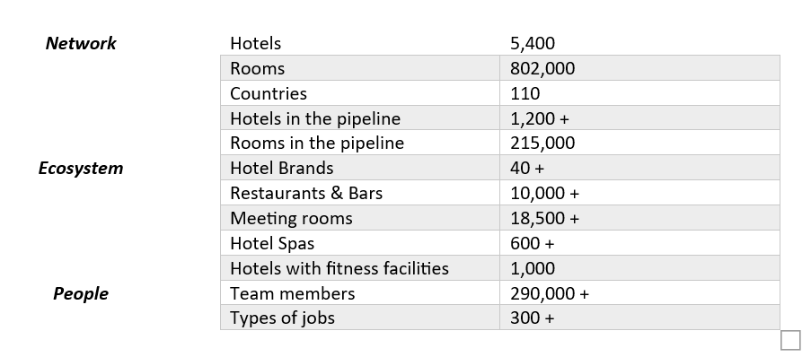

# Founders

**Gérard Pélisson (1932.2.9 – 2023.3.6)**

Gérard Pélisson was a French hotelier and businessman. He was a graduate of MIT and was the president of the Union des Francais de l’Etranger. He co-founded the Accor Group with Paul Dubrule in 1967. He died on March 6th, 2023 at the age of 91.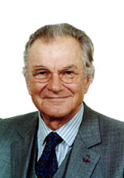

**Paul Dubrule**

Paul Dubrule is a French Businessman and politician. He graduated from the University of Geneva. He was a member of the French Senate from 1999 to 2004, representing Seine-et-Marne. He co-founded the Accor Group with Gérard Pélisson in 1967.

**Brief History**

Dubrule and Pélisson, both living in the United States in the 1960s, noticed the success of American lodging properties that were located in suburban areas and along major highways. The two decided to bring that idea to France, opening their first American-style Novotel hotel. Soon, the company expanded to include locations at airports and popular vacation sites along seasides and in mountain regions. Accor Group was born.

They served as co-chairmen, expanding the company rapidly. They acquired a two-star hotel chain and purchased Mercure, a large hotel chain in the late 1970s. With the acquisition of Sofitel Hotels in 1982, Novotel and its holdings were integrated under the name Accor. They soon entered the US market by bringing hotels and seafood broiler restaurant chains. Moreover, they invested in Italian restaurants, partnered with bakeries, and entered the travel industry.

# Board of Directors

**Sébastien Bazin *– chairman and CEO***

Sébastien holds a degree in economics and a master’s degree in management. He also served as group chairman and Luxury & lifestyle division CEO. He had experience in investment banking, real estate investing, and hospitality for over 38 years. He joined Accor’s Board of Direction in 2005.

**Iris Knobloch *– Independent Director, and Vice-Chairman***

Iris holds a J.D. degree from Ludwig-Maximilians-Universität Munich and an LL.M. degree from New York University. She is also the President of the Cannes Film Festival, Chair of the Board of Directors of Deezer, and a member of the Board of Directors of Banque Lazard Ltd.

**Asma Abdulrahman Al-Khulaifi – *Director***

Asma holds a LL.M in international trade and investment law. She had experience in advising the government on trade law matters. She was appointed as a director in 2022.

**Ugo Arzani *– Director***

Ugo holds a degree in Business Administration from Bocconi University of Milan Magna Cum Laude. He had 15 years of experiences at Merrill Lynch in Investment Banking division. He was appointed as a director in 2022.

**Hélène Auriol Potier *– Independent director***

Hélène holds a master’s degree in Engineering from Telecom Paris and a MBA from INSEAD. She used to serve as CEO of Microsoft Singapore, Managing Director of Microsoft Dynamics Europe, and Managing Director of Artificial Intelligence Europe. She was appointed as a director in 2022.

**Iliane Dumas – *Director representing employees***

Iliane is a graduate of École de Paris des Métiers de la Table. She joined the Accor Group in 1991 and was initially part of the sales team. She is also a Senior Project Manager within the Group’s Talent & Culture Department.

**Qiong’Er Jiang *– Independent director***

Qiong’Er is a graduate of the design school at Tongji University. She was awarded the titles of Chevalier des Arts et Lettres and Chevalier de l’Ordre National du Mérite by the French President. She was appointed as a director in 2016.

**Anne-Laure Kiechel – *Independent Director***

Anne is a graduate of HEC and the University of St.Gallen. Before joining Accor, Anne was a managing partner of Rothschild & Cie. She was appointed as a director in 2023.

**Bruno Pavlovsky – *Independent Director***

Bruno is a graduate of Bordeaux École supérieure de commerce and holds an MBA from Harvard Business School. He is currently Chairman of Chanel SAS and Chanel’s President of Global Fashion. He was appointed as a director in 2020.

**Nicolas Sarkozy – *Independent Director***

Nicolas was the President of the French Republic from 2007 to 2012. He was appointed as a director in 2017.

**Christine Serre – *Director representing employees***

Christine is a graduate of the Bordeaux Hotel School. She joined Accor in 1992. She was appointed as a director in 2021

**Isabelle Simon – *Independent Director***

Isabelle is a graduate of Sciences Po Paris, HEC, and Harvard Law School. She holds a DEA postgraduate diploma in English and North American business law. She was the Executive Director of Goldman Sachs and Vice-President of Société des Bains de Mer de Monaco. She was appointed as director in 2016

**Sarmad Zok – *Director***

Sarmad holds a degree in Hotel Management from University of Surrey and a Master’s degree in Property Valuation and Law from City University Business School in London. He has experience in hotel investment. He was appointed as director in 2016.

# Executive Team

**Sébastien Bazin *– CEO***

Sébastien holds a degree in economics and a master’s degree in management. He also served as group chairman and Luxury & lifestyle division CEO. He had experience in investment banking, real estate investing, and hospitality for over 38 years.

**Jean-Jacques Morin - *Group Deputy CEO and Premium, Midscale & Economy Division CEO***

Jean Hold an MBA from Arizona State University and is qualified with the French Institute of Chartered Accountants. He was the CFO Alstom before being appointed Group CFO at Accor.

**Martine Gerow – *Group Chief Finance Officer***

Martine graduated from HEC and holds an MBA from Columbia Business School. She served as CFO for Carlson WagonLit Travel, American Express Global Business Travel, Solocal, and Campofrio before joining Accor.

**Besma Boumaza – *Group General Counsel & Board of Director’s Secretary***

Besma is a qualified lawyer with a master’s degree in international law. She also served as an independent director at Dassault Aviation and Vice President of the Board of the French Association of in-house counsels.

**Steven Daines *– Chief Talent & Culture Officer***

Steven holds an MBA in hospitality management from international business school ESSEC. He was the regional CEO at Accor from 2014 to 2017 and was appointed Chief Talent & Culture Officer and member of Accor’s Executive Committee in 2019.

**Brune Poirson – *Chief Sustainability Officer***

Brune is a graduate of London School of Economics and Aix-en-Provence Institut d’Etudes Politiques. She also holds a Master’s degree from the Harvard Kennedy School of Government. Brune was appointed Secretary of State for the Environmental Transition and Vice president of the United Nations Environment Assembly.

**Kamal Rhazali – *Secretary General; and General Counsel, Luxury & Lifestyle***

Kamal holds several law degrees from the Sorbonne University and had experiences in top tier law firms. He joined Accor in 2023. He assists in setting up the luxury & lifestyle division, defining its strategy and ensuring its consistent implementation.

**Floor Bleeker – *Chief Technology Officer***

Floor Holds a Bachelor’s degree in Hotel Administration from Hotelschool The Hague and an MBA from the University of Colorado. He had over two decades of multinational experience in the hospitality industry and in IT leadership strategy development.

**Alix Boulnois – *Chief Digital Officer***

Alix holds a master’s degree in Strategy and Management from HEC Paris and an MBA from Columbia Business School. She used to took the lead at McKinsey & Company and Amazon. She joined Accor in 2020 and oversees digital transformation, innovation, engineering, and development.

**Caroline Tissor – *Chief Procurement Officer***

Caroline is a graduate of the Institut d’Etudes Politiques de Paris and holds a Master’s degree from the University of Paris Dauphine. She had over 10 years experience in Procurement and joined Accor in 2016. She is developing the Group Procurement Organization which references and supplies Accor’s hotels around the world with services they need for their construction, refurbishment, and daily operations.

# Shareholding Structure

**Accor shareholding at December 31, 2022**

At December 31, 2022, the Company’s capital consisted of 263,031,794 shares, representing a total of 343,613,319 voting rights, all of which were exercisable.

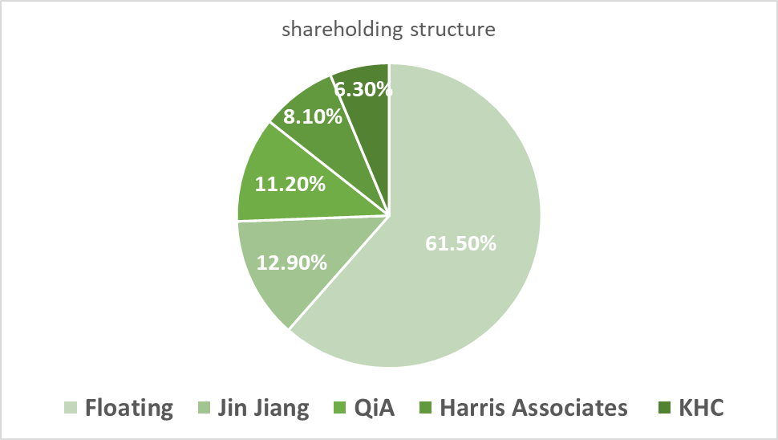

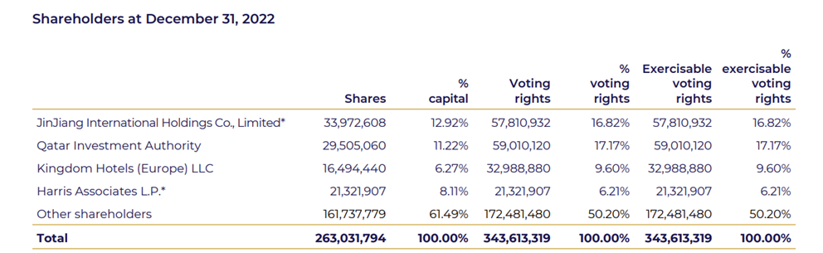

# Product Positioning

Accor has structured its core business around the concept of augmented hospitality, reflecting a sophisticated vision of hospitality and bespoke services to provide guests, travelers, workers, and local residents unique experiences.

**Brand Portfolio**

Accor is much more than a mere hotel group. It has a comprehensive and diverse ecosystem of brands, expertise, and solutions.

***Live:*** From luxury to Economy, Accor has over 40 brands and 802,000 rooms in its ecosystem. It provides customers with relaxing and personalized living experiences.

***Work:*** With over 18500 meeting rooms and coworking areas, Accor enables customers to work during their stay.

***Events & Catering:*** With over 10,000 bars and restaurants, Accor creates lively experiences for both the locals and the travels.

***Wellness:*** With more than 600 hotel Spas, 1,000 fitness clubs, and 14 Thalassa wellness center, Accor provides revitalizing seawater therapies, holistic treatments, and advice on fitness to its customers who are looking for services and experiences that help keep them in shape.

***Unrivaled Expertise in the residential segment:*** Accor provides residential services for longer stays and upscale private residences. It has more than 60,000 apartments, villas, and chalets.

**Target Market and Customer Segments**

***Leisure Travelers:*** Accor provides a wide range of options for leisure travelers, from luxury hotel to budget-friendly accommodations, catering to different preference and travel budget.

***Families and Group Travelers:*** Accor’s family-friendly hotels provide kid-friendly services, including kid-friendly breakfast, Kid Clubs, Kiddie pools etc.

***Business Travelers and Corporates:*** Accor has over its 3,100 seminar hotels and 18,500 meeting spaces available for its business guests. With the cutting-edge technological equipment and innovative F&B offerings, Accor can accommodate more than 700 events each day.

***Luxury Seekers:*** Accor's luxury hotel brands, such as Sofitel, cater to high-end travelers seeking premium experiences.

**Customer Relations**

***Accor Customer Digital Card Database***

Accor’s Customer Digital Card Database enables all group hotels to share their knowledge of guests, such as consumption habits, special needs, etc. It enables Accor to personalize the relationship with customers, and helps Accor to better understand customers’ preference and needs.

***“All-Accor Live Limitless” program***

“All-Accor Live Limitless” is an experiential loyalty program. The members have access to a comprehensive range of services and experiences. It also rewards customers with points for redeeming special offers, discounts, and other benefits. All rewards are simple and transparent (2,000 points = €40) with no black-out dates. Collaborating with 90+ industry-leading international partners, Accor offers hundreds of ways to earn and redeem points, such as ticketing and entertainment with Fever, co-branded card payments, cross-rewards partnerships with Qantas and Qatar Airways, etc.

**Distribution Channels:**

Accor has various ways to reach its customers. Customers can book hotels through mobile apps, search engines, websites, and other platforms.

**Differentiator**

***Sustainability***

Accor has a strong emphasis and commitment to sustainability. It aims to make a positive impact on both people and nature, which are two fundamentals at the core of the hospitality sector.

Accor committed to achieve net zero carbon emission by 2050 and engage in absolute reduction of greenhouse gas emission. It also embraces a sustainable food chain that sources food more responsibly to preserve biodiversity and reduce environmental impact. It further embedded sustainability into its business by integrating Environmental, Social, and Governance criteria into its financing strategy.

***Innovation***

Through innovation partnerships with start-ups, large groups, and schools, Accor develops a co-development and co-creation approach that enables faster anticipation of changes and challenges. Its partnership with top schools worldwide consolidates its attractiveness among educated students and helps it to get a new and innovative vision. Moreover, Its partnership with start-ups allows them to get new ideas that might change the hospitality sector in the future.

# Competitive Analysis Globally

**Direct Competitors**

Accor’s major competitors are **Marriott International**, **Hilton Worldwide Holdings**, **InterContinental Hotel Group**, **Hyatt Hotels Corporation**, and **Wyndham Hotels & Resorts**. Just like Accor, all these companies are multinational, and they all have a comprehensive ecosystem that incorporate not only hotels, but also other services such as wellness and entertainment.

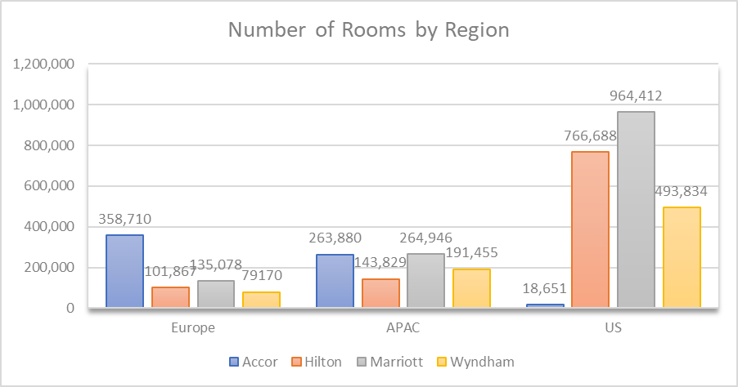

We can tell from the graph that Accor outperforms its competitors in Europe and APAC region, while performing relatively poorly compared to competitors in the US. It might be because those competitors are based in America, so there will be more market share than Accor, which is a French company.

Comparing the Revenue per available room of Accor and its competitors:

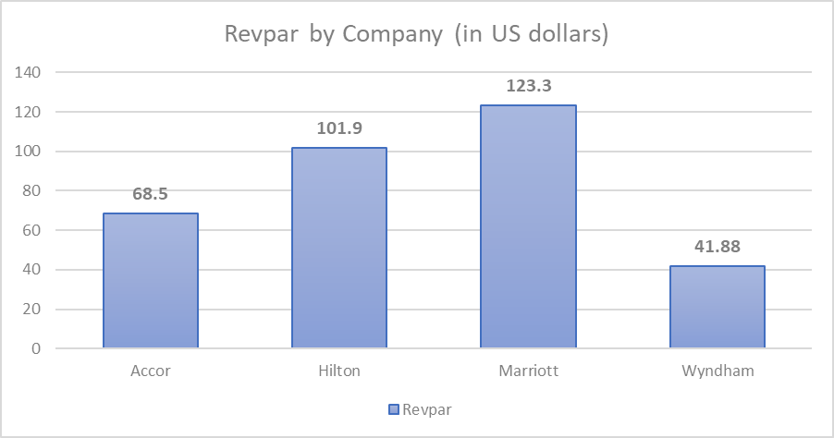

Comparing number of brands Accor and its competitors own:

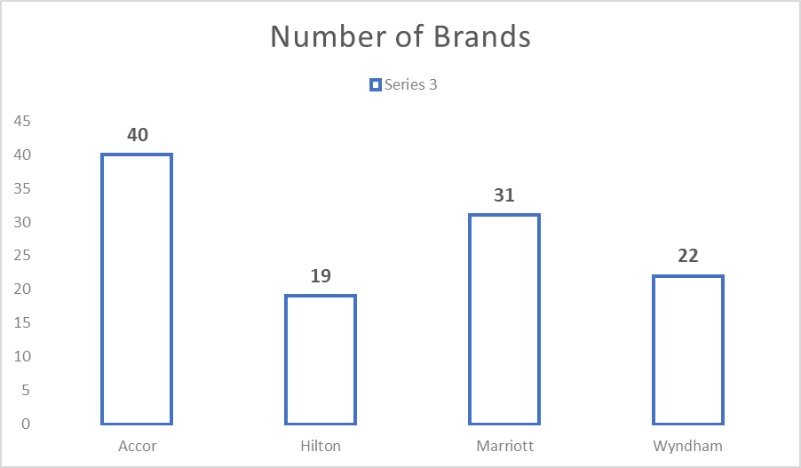

comparing net income between Accor and its competitors:

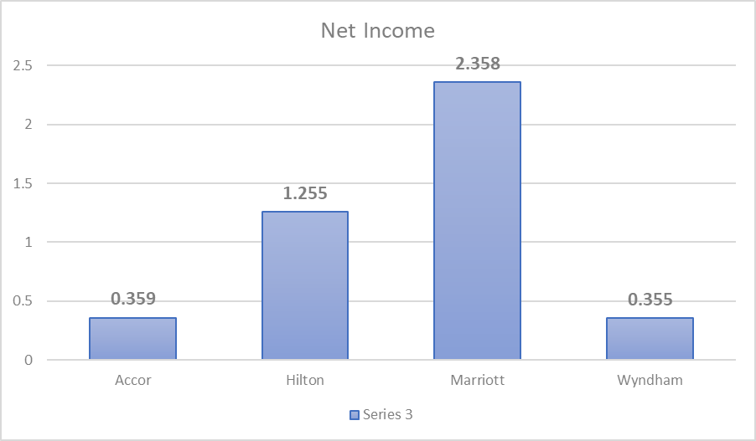

**Indirect Competitors**

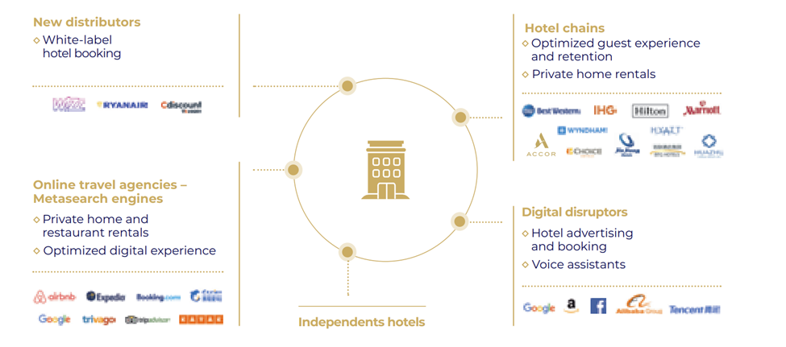

***Online Travel Agencies***

With the development of technology and digitalization, there’re more Online Travel Agencies such as Expedia, Booking.com, etc that offer a wide range of hotel options. This may affect Accor by diverging customer’s attention. Since there are more available options online, customers may choose other instead of Accor.

Moreover, those online travel agencies can quickly collect a great deal of personal information about customers, grasp their consumption habits, and offer them a wide choice according to their profile. This will hinder Accor from making a direct and personalized relationship with customers.

***Private Home Rental Platform***

The emergence of home rental platforms such as Airbnb offers an alternative to traditional hotel stays. This can divert potential customers away from Accor as travels are given more options. Moreover, home rental offers lower prices, therefore appealing to travelers with lower budgets.

# 10K Research

***Income Statement***

According to the disclosures that Accor made about its revenue, the company has three distinct sources of income, namely management and franchise, services to owners, and hotel assets and other.

The first segment management and franchise includes the revenue from managing hotels for Accor’s franchisees and the income from procurement commission. Accor has this type of revenue from its franchises in five different geographic regions: Southern Europe, Northern Europe, Asia Pacific, Americas, and Others (including India, Middle East, Africa, Turkey).

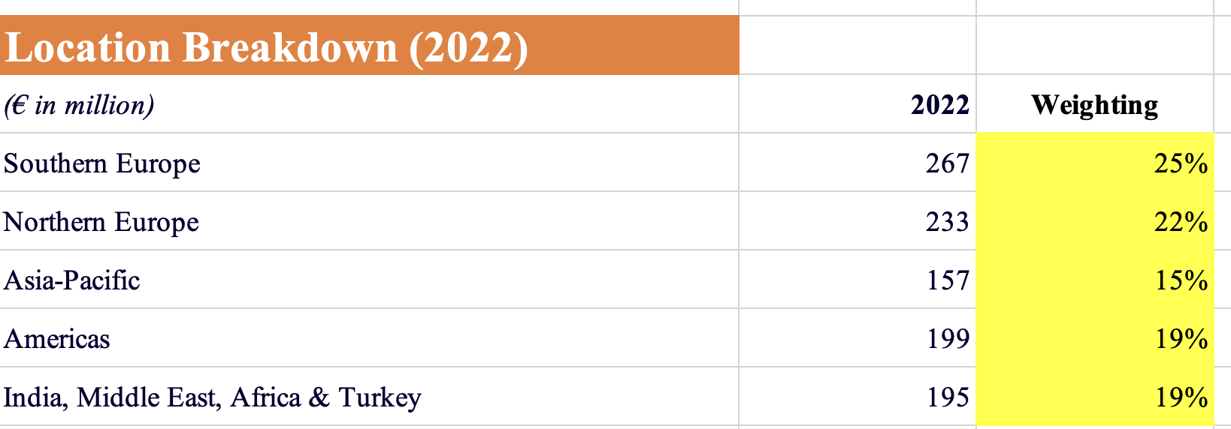

The table above lists the breakdown of Accor’s 2022 management and franchise revenue from each of its five regions. As shown above, the biggest contributor is Southern Europe (which includes France) and Northern Europe, providing 25% and 22% of the revenue respectively.

The second segment services to owners contains Accor’s revenue as a supportive hotel operator. The major components of this segment include sales support, marketing services, use of Accor’s loyalty program, and other cost reimbursements. The last segment hotel assets and other includes the revenue Accor makes from operating the hotels that it actually owns. This type of income is generated from providing accommodations and providing food and beverages. The last income segment also includes revenue from new business activities such as hotel booking services and the Accor Plus reward program.

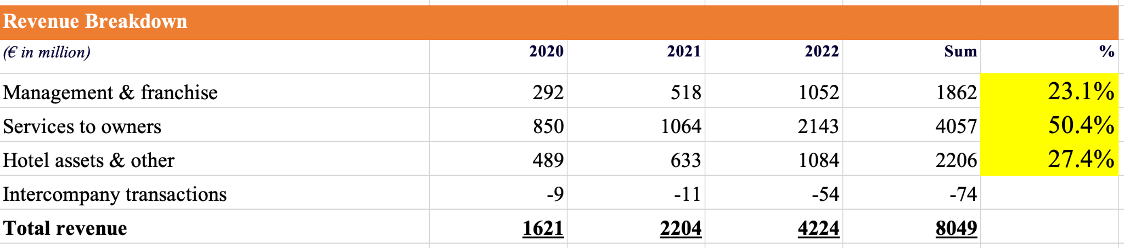

The table above is the breakdown of how much revenue Accor has from each of its three income segments in the last three reported years. As shown above, over half of Accor’s revenue in the last three years came from the services to owners segment. This resonates with Accor’s claimed strategy of transitioning to an asset light business model as Accor is generating more revenue as a services provider and hotel operator as opposed to a hotel owner.

***Balance Sheet***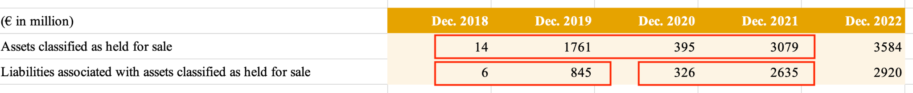

The most noteworthy line items on Accor’s balance are assets classified as held for sale and liabilities associated with assets classified as held for sale. Accor underwent major acquisitions in 2018 (such as the acquisition of Mantra Group), but its long-term financial debt from 2017 to 2018 did not change drastically as a result of the preparation for the M&A activities. Nonetheless the asset held for sale of 4824 million Euros in 2017 dropped to just 14 million in 2018 indicating that the sale of assets was a major source for financing. It is also interesting to note that Accor’s cash reserve from 2017 to 2018 also spiked by 1757 million.

# Analysis of the Financials

***Capitalization Requirements***

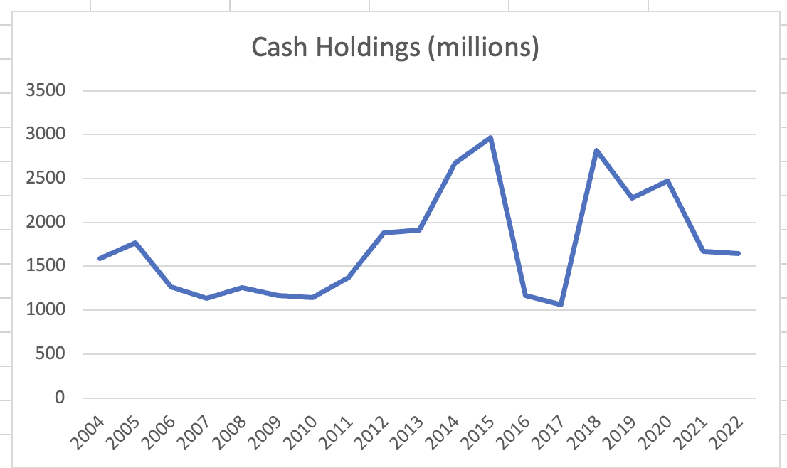

The graph above illustrates Accor’s change in cash reserves. There are two major changes in cash: the sharp decline from 2015 to 2016, and the sharp increase from 2017 to 2018. The drop in cash in 2015 is likely due to the acquisition of FRHI Holdings as mentioned in the M&A section of the report. As mentioned in the balance sheet analysis, the spike in cash in 2018 can be attributed to the sale of assets for the strategic transition to the asset light model and for the preparation of the Mantra Group acquisition.

# *Break-even Analysis*

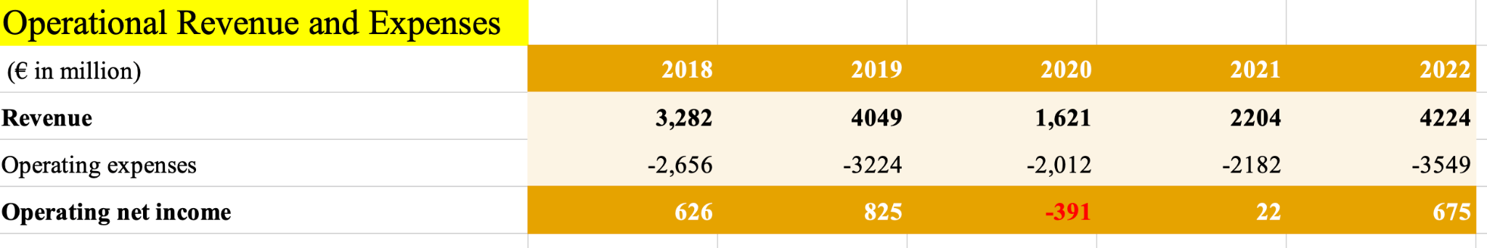

The table above lists the net operating income of Accor for the last five reported years. As shown, Accor was able to have positive operating net income for every year aside from 2020 due to the impact of the pandemic.

# *Capital Structure*

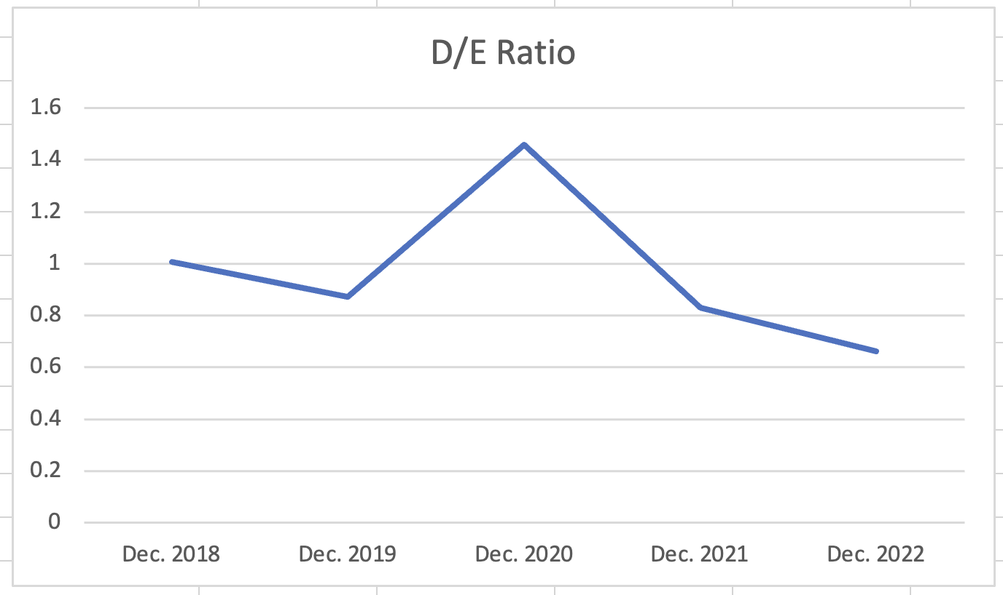

The graph above illustrates Accor’s debt to equity ratio over the last five years. The ratio appears to fluctuate within the boundaries of 0.6 to 1 if we omit the anomaly in 2020. In the 2020 fiscal year, the pandemic led to a significant decline in Accor’s net income, which in turn lowered its equity account by a huge degree. Accor’s debt to equity ratio range indicates that it does not rely heavily on debt financing, meaning that the company has relatively lower financial and liquidity risk. As shown on the graph below, Accor’s debt to equity ratio resembles the average ratio for the global hospitality industry even though its business is more diversified and has an emphasis on an asset light strategy.

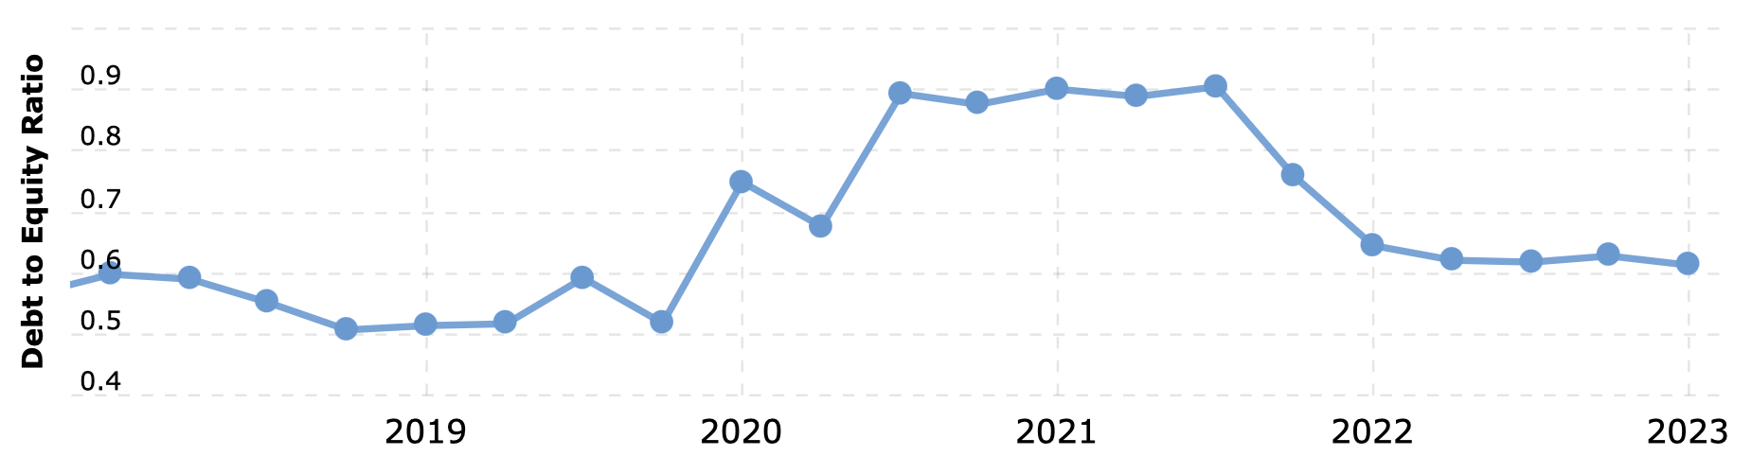

# *FCF Analysis*

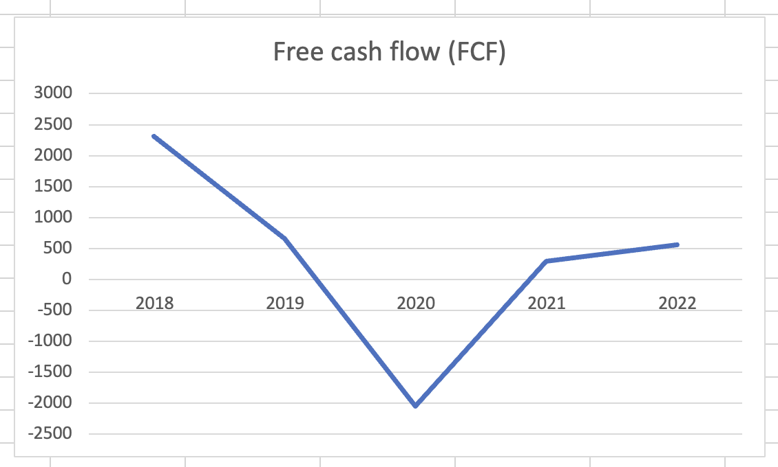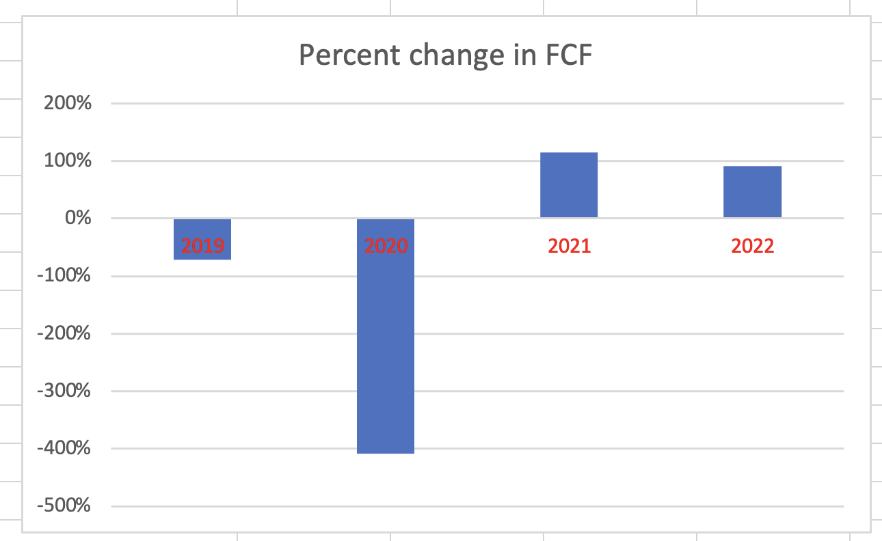

The two charts above illustrate Accor’s free cash flow and percent change in free cash flow. As shown above, Accor suffered a significant decrease in free cash flow in 2020 as a result of the pandemic, but its performance started to recover in 2021.

# DCF Analysis

The first step of the DCF analysis is to compute the growth rate of Accor’s EBITDA. Due to the impact of the pandemic, the EBITDA starting from 2020 is drastically altered from what it would have been so the average growth rate before the pandemic was computed. Nonetheless, it is important to factor in the potential for future anomalies and various risks further explored in the next section of the report so only 2020 was completely omitted and the 2021 and 2022 growth rate were computed based on growth compared to pre-pandemic levels. A 50/50 average of the overall average growth rate and the pre-pandemic average produced an EBITDA growth rate of 4%.

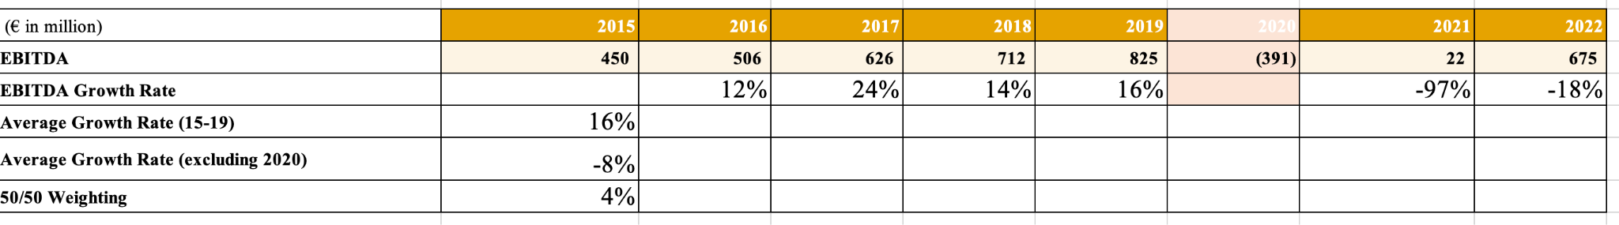

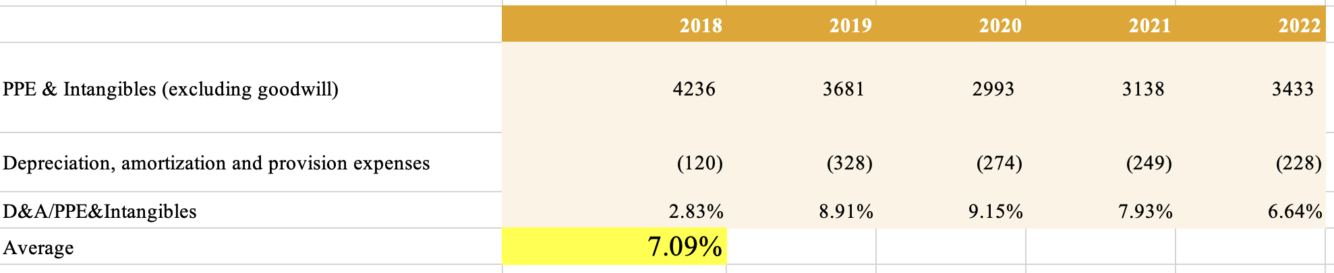

The second step was to forecast the depreciation and amortization expense per year. The assumption used in this step is that the ratio of D&A expense over Accor’s assets does not fluctuate outside an unreasonable range. To compute the predicted D&A expense, the historical D&A expense levels are listed and then divided by property plants and equipment and intangibles excluding goodwill. Goodwill is excluded because it undergoes impairment tests instead of being amortized. The average of the percentage is then computed as 7.09%.

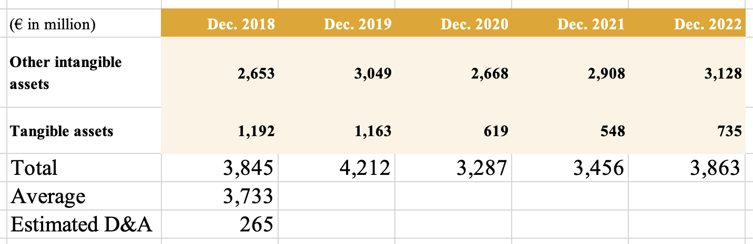

To compute the estimated D&A expense, the percentage from above is applied on the average of the last five reported year’s tangible assets plus other intangible assets to produce 265 million Euros.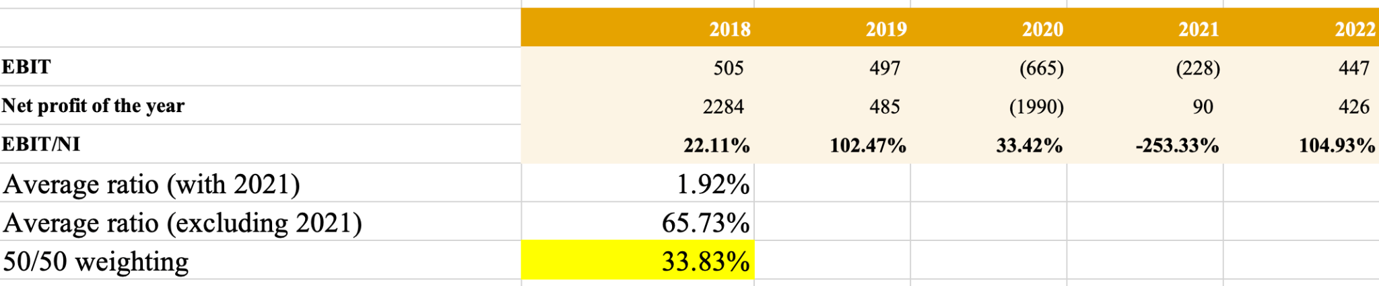

The third step was computing the ratio of EBIT over net income. 2021 was an anomaly, so a 50/50 average of the average ratio with 2021 and the ratio without 2021 was computed. The percentage was 33.83%.

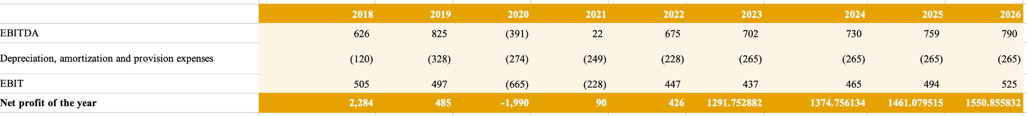

The fourth step was computing the net profit of the year from the estimated EBITDA, D&A expense, and percentage of EBIT over net income. The D&A expense is subtracted from the EBITDA to compute the EBIT, and then the EBIT multiplied by 33.83% produces the net profit of the year.

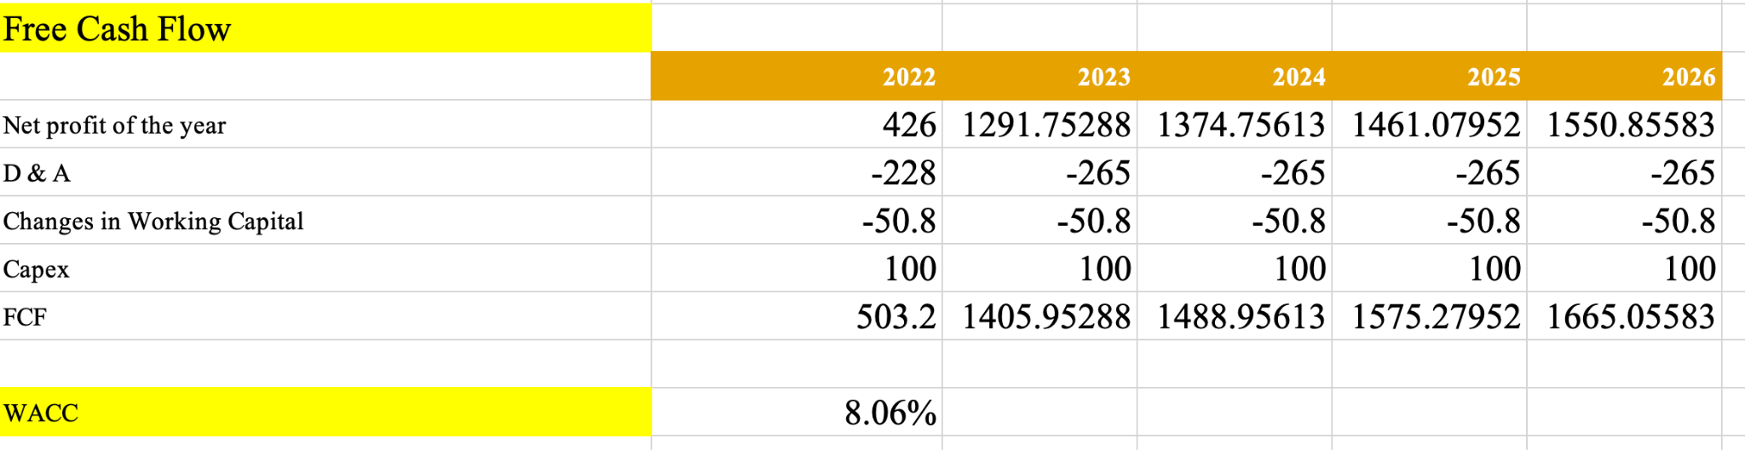

The fifth step was forecasting the free cash flow by adding back the D&A expense, subtracting the average change in working capital, and adding back the capital expenditure.

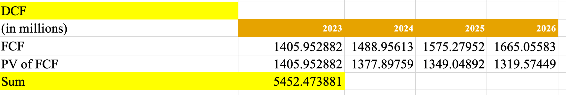

With a WACC of 8.06%, the net present value of the forecasted future free cash flow is then computed. The sum of the present value of the free cash flow is 5452.5 million Euros.

The sixth step was computing the terminal value after 2026. The long-term growth rate for the perpetuity was computed based on the average growth rate of Accor’s revenue. Nonetheless, the average growth rate is much higher than IBIS World’s projection of the hospitality industry’s forecasted market growth rate of the hospitality industry, so a 9/1 weighting was used to compute the long-term growth rate as 1.84%. Although Accor has transitioned into an asset light business model and relies less on operating hotels they own, all three of its income segments are highly correlated with the hospitality industry. Accor’s biggest segment services to owners is especially linked to the conditions in the industry as a decline in the hospitality industry would lead to a decrease in the demand for Accor’s supportive services and furthermore the capacity to expand. 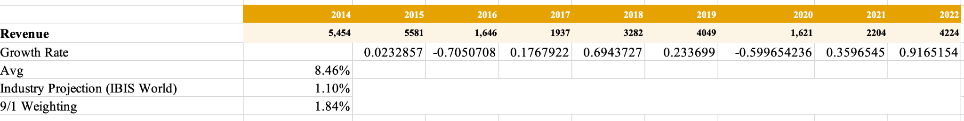

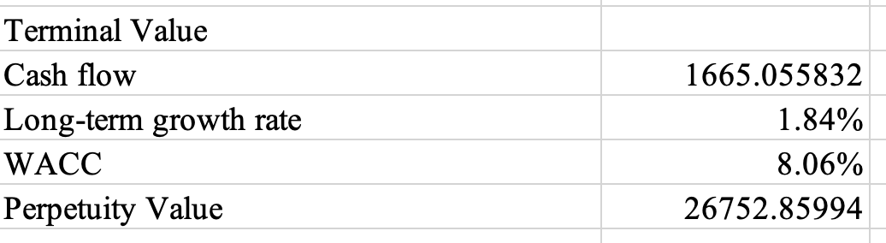

With the long-term growth rate and the WACC, the perpetuity value is computed as 26,752.9 million Euros.

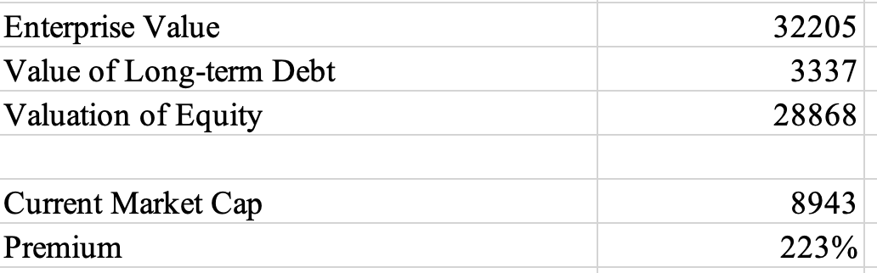

The final step was adding the present value of the estimated cash flows with the terminal value to get the enterprise value, and subsequently subtracting the value of the long-term debt from the enterprise value to get the value of equity. The value of equity was computed to have a 223% premium over Accor’s current market capitalization. This conclusion is clearly unreasonable, largely caused by the volatility in Accor’s financials from impacts of the pandemic and changes from its strategic transition. Therefore, only the processes involved in the DCF analysis can serve as references to the analysis of the company.

# 

# Risk Management

**Foreign exchange risk**

As a multinational hospitality company, Accor can be affected by the fluctuations in foreign exchange rates.

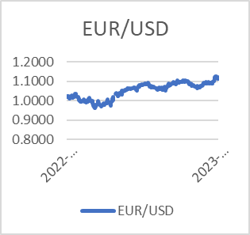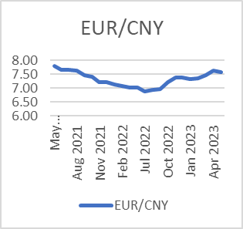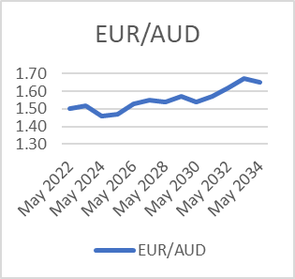

As we can see, the Euro is appreciating against the currency of the countries that Accor operates in. This will incur negative impact on Accor’s non-European operations, as there might be a reduction in revenue when converting currencies into Euros for financial reporting. Moreover, the exchange rate fluctuations may also impact Accor’s competitiveness. As Euro becomes stronger relative to other currencies, it makes European hotels relatively more expensive for international tourist, potentially leading to a decrease in booking volumes from non-Eurozone countries.

**Interest rate risk**

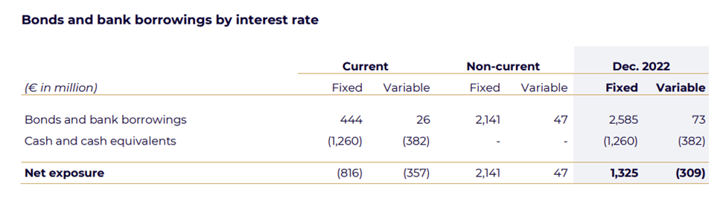

As of December 31, 2022, 97% of bonds and bank borrowing were at a fixed rate, with an average rate of 2.1% and 3% were at a variable rate, with an average of 5%. The fixed rate debt is denominated primarily in euros.

The 97% fixed rate borrowing won’t be affected by the fluctuations in the interest rate, as Accor’s expenses on loans will remain constant over time. This provides stability in interest cost and makes interest payment more predictable.

The 3% variable rate borrowing makes Accor exposed to the fluctuations in interest rates. However, since there’s only a small portion of variable borrowing, the exposure to the risk is relatively low.

Beside the effect on Accor’s borrowing, the fluctuations in interest rates may also affect the customers’ behaviors. As interest increases, people are more likely to save money and borrow less money, therefore the demand for traveling and hotels decreases. This decrease in demand will lead to a decreases in revenue and profit.

Moreover, the fluctuations in interest rates can also affect Accor’s expansion. One of Accor’s strategies is to expand through acquiring different hotel brands. If the interest rate increases, the financing cost will increase as well.

**Liquidity risk**

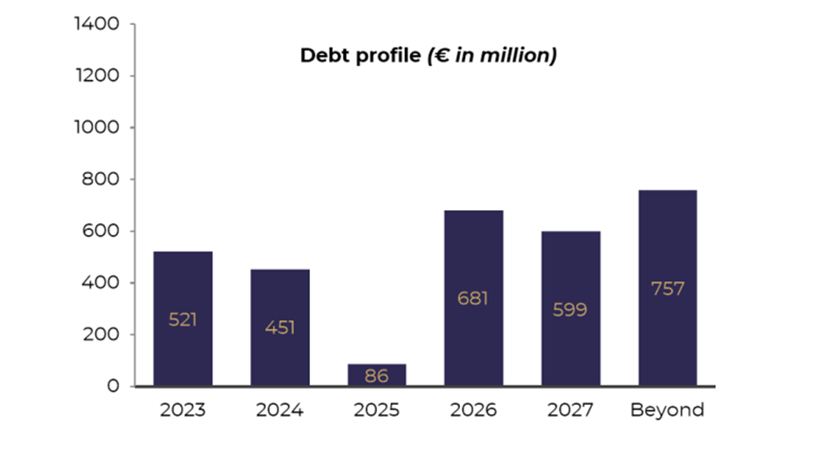

Accor’s debt structure can incur liquidity risk if it matures during the period when Accor is experiencing stress in cash flow. However, there is no early repayment clause, so Accor can make better plans and schedules to repay the debt, without the exposure to liquidity risk resulting from unexpected need to repay debt earlier.

Accor also has one undrawn confirmed credit line for €1,200 million, maturing in June 2024 (for €86 million) and in June 2025 (for €1,114 million). Since the group has undrawn credit, it has access to additional credit if needed. Therefore, Accor’s liquidity position is enhanced.

Besides liquidity risk arises from debt, Accor may also expose to liquidity risk arises from fluctuations in revenue, changes in economic conditions, and occurrence of unexpected events. Firstly, since tourism often experiences seasonal variations, Accor may have low revenue and low cash flow during low-demand seasons. Therefore, it may not have enough cash to cover the expenses. Second, during adverse economic condition, people’s demand for traveling decreases, and this may affect Accor’s revenue and cash flow. Moreover, unexpected events such as natural disasters, pandemics, or war will also affect the cash flow. For example, during the COVID-19 lock down, tourism in most of the countries is negatively affected. With traveling restrictions and social distance measures, hotels experienced sharp decline in cash flow, making it challenging to cover cost.

**Climate change risk**

According to the report, approximately 10% of hotels could be threatened by flooding due to climate change and approximately one-third of the hotels would see a threefold increase in extreme heat waves, resulting in higher capital cost, operational cost, and lower room rates.

Moreover, there might be a decline in business travelers, particularly long-distance travelers since lots of companies are committed to carbon reduction and are forced to reduce the amount of business travel. Also, Accor is also committed to carbon reduction, so the cost of operation is likely to increase through taxes and carbon-reduction mechanism.

**Geopolitical Risks**

The geopolitical conflict can affect Accor’s operation and revenue. For example, the Russia-Ukraine war is a threat that will adversely affect the world economy and therefore the hotel industry.

Due to the war, the energy price surged, supply chain is disrupted, and the labor market is also affected. Therefore, Accor may experience a decline in revenue and room rates.

Moreover, operating in 110 countries, Accor can be influenced by terrorist attack in host countries. The existence of large-scale attacks may hinder tourists from traveling and also harm the local labor markets.

**Cyber Risk**

Accor has a network that shares customers’ information and data (including personal data and payment data) between each hotel brand. The data can be subject to malicious use. For example, the service provider could be victims of cyber-attacks or sabotage intrusion that harm the confidentiality of the data.

**Operational Risk**

Accor operates in over 110 countries and each countries have different and complex laws and regulatory environment. Failure to comply with these regulations may expose Accor to sanction and damage to its reputation. Also, since Accor has an extensive network and ecosystem of partners. This organizational complexity exposes Accor to the risk of non-compliance and corruption as it might be hard to closely monitor and regulate each partner.

# Stock Price Analysis

**Stock Price Since IPO**

On July 19, 1983, Accor became a publicly traded company, initially traded in francs. In September 2000, Euronext was established through the merger of the stock exchanges in Amsterdam, Brussels, and Paris. Subsequently, Accor has been listed on the Euronext Paris stock market under the stock code FR0000120404.

Accor originally went public again on January 20, 1989, with an IPO price of approximately €12.01, although the specific valuation at that time is unknown. Fast forward to July 25, 2023, the closing price of Accor's stock stands at €37.90, resulting in a market capitalization of approximately €9.87 billion.

**Stock Price Growth Since IPO**

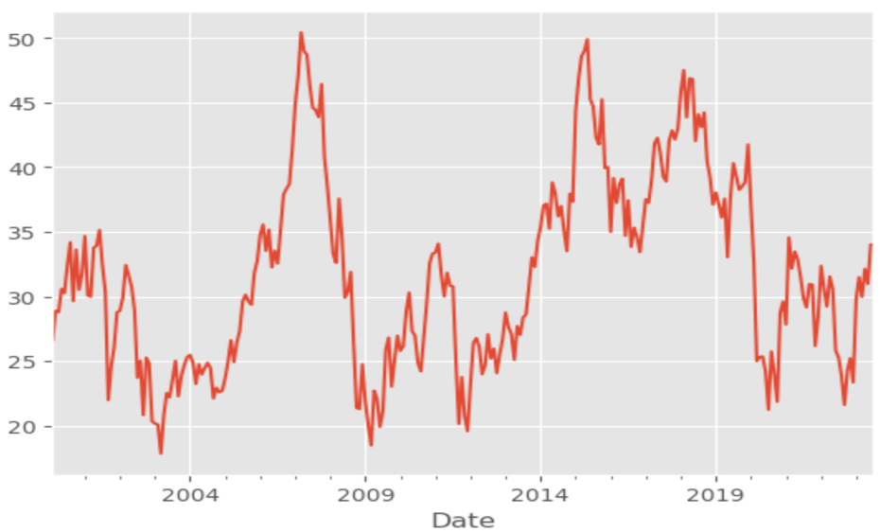

Based on the stock price from Euronext, the company's stock has experienced significant ups and downs.

The first remarkable peak occurred in 2008. During the period from October 10, 2002, to July 11, 2007, the stock price underwent a remarkable surge of approximately 201.08%. This surge equates to an increase of €35.45, more than doubling the stock price from €17.63 to €53.08. This ascent marked the highest stock price within this 23-year timeframe, illustrating significant growth. Subsequently, the stock price experienced a decline, reaching a nadir of €17.76 on March 30, 2009, resulting in a price difference of -€35.32. This decline translated to an approximate decrease of 66.57% during this phase. Following this decline, the stock exhibited resilience and rebounded. The second notable peak emerged in 2015.

From January 9, 2012, to April 22, 2015, the stock price exhibited an impressive rise of approximately 176.34%, reflecting a gain of €32.95 and propelling the stock price from €18.7 to €51.65. This achievement stood as the second-highest stock price within the 23-year span, showcasing substantial growth over this stretch. The stock price then experienced a minor descent, touching a low point of €20.15 on May 14, 2020. This decline led to a price difference of -€21.69, representing a decrease of approximately 41.99% during this interval. Once again, the stock demonstrated its capacity to recover.

The third notable peak was observed in 2018. From February 11, 2009, to May 28, 2018, the stock price displayed an increase of approximately 63.43%. This corresponds to a gain of €18.99, propelling the stock price from €29.96 to €48.95. This achievement marked the third-highest stock price across the 23-year span, signifying significant growth during this period. However, the stock price subsequently experienced a decline, particularly in 2020 due to covid-19, descending to a low point of €29.96 on February 11, 2009. This resulted in a price difference of -€31.50, reflecting a decrease of approximately 61.02% over this phase.

**Year by Year Stock Price Highs and Lows**

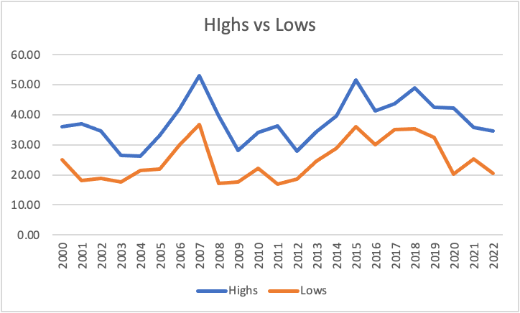

Stock Price Highs

**07/11/2007 €53.08 (Highest)**

04/22/2015 €51.65

05/28/2018 €48.95

06/30/2023 €34.40 (This year)

Stock Price Lows

**12/14/2011 €17.03 (Lowest)**

10/27/2008 €17.07

10/10/2002 €17.63

01/01/2023 €23.39 (This year)

Last, the market capitalization, as shown by the following diagram (in USD), has exhibited fluctuations over the years. The decline in market cap in 2020 (-24.9%) and 2022 (-21.99%) is influenced by the COVID-19 pandemic's impact. The highest market cap was recorded in 2007 at $17.69 billion, followed by a sharp decline of 42.6% in 2011. However, despite some challenging periods, recent years have demonstrated a positive trend. In 2023, there was a notable increase of 51.64% in market cap, indicating substantial growth compared to the previous year.

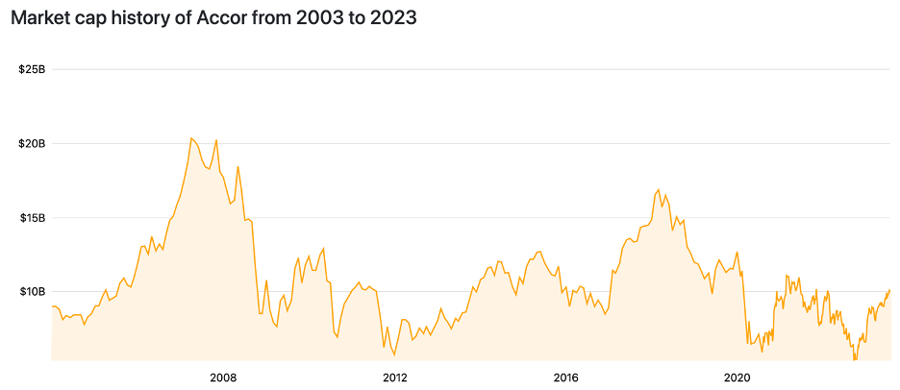

Resource from: companiesmarketcap.com

**Stock Price Moving Average Analysis**

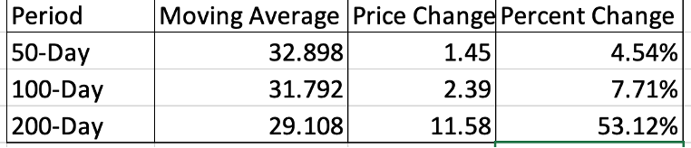

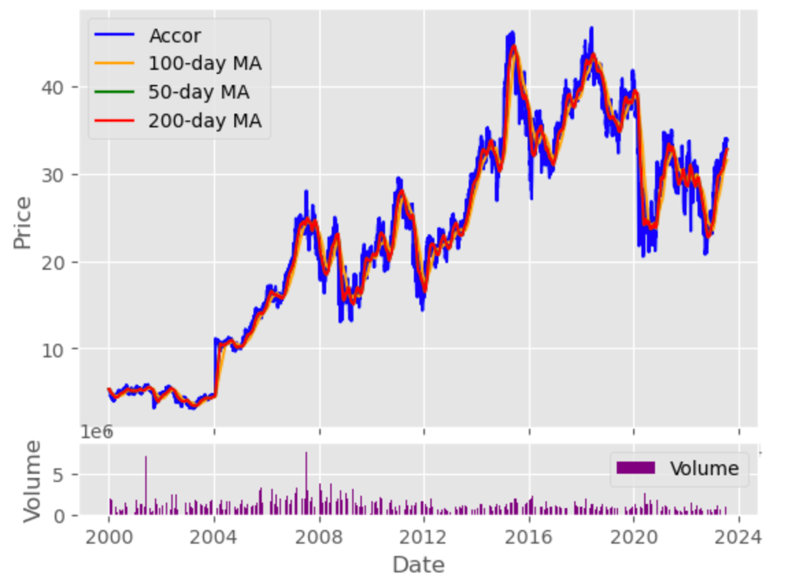The stock price moving average analysis suggests positive trends in the company's stock performance over different time periods. The 50-day, 100-day, and 200-day moving averages all show upward trajectories, indicating potential growth.

P/E = 27.46

Stock Price = 37.90

Diluted EPS = 1.38

Positive Earnings:Positive earnings and a solid EPS imply that the company is generating profits and has the potential to continue growing, thus attracting investors and contributing to the upward trend in the moving averages. In conclusion, with positive earnings and a solid diluted EPS, the company appears to be in a healthy financial position. Positive earnings can be positively influenced by successful M&A deals that contribute to revenue growth and cost synergies.

**Price/Earning Ratio 6 Years:**

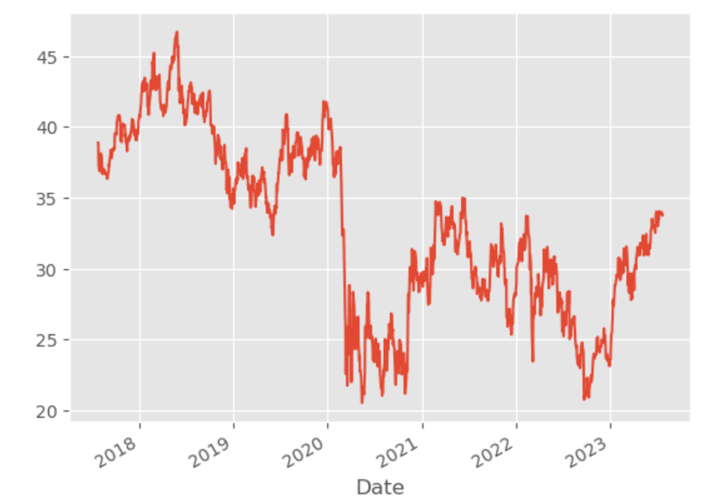

Over the past six years, Accor has exhibited a volatile Price/Earnings (P/E) ratio, averaging at -152.44x. Accor's P/E ratio decreased in 2018 (-791.5x), 2020 (-4.0x), and 2021 (-30.1x) and increased in 2017(40.4x) in 2019 (36.8x) and 2022 (26.6x). Looking back at the last 6 years, Accor's p/e ratio peaked in December 2017 at 40.4x. Accor's p/e ratio hit its 6-year low in December 2018 of -791.5x. This indicates that Accor faced challenges in generating sustainable earnings relative to its stock price during those periods, influenced by the impact of M&A activities and their integration into the company.

In contrast, its top two competitors, IHG and Marriott, have demonstrated more stable P/E ratios, with IHG averaging at 44 and Marriott at 87.94 over the same period. Although Accor's P/E ratio improved in subsequent years, it remained in negative territory during 2020 and 2021, indicating challenges in generating sustainable earnings relative to its stock price. In comparison, both IHG and Marriott generally maintained positive P/E ratios, indicating a healthier earnings outlook in relation to their stock values.

# Index Performance

From the code by python

Writing program code in Python starts by referencing key packets and setting start and end times.

Listed on the Euronext Paris (stock code: FR0000120404).

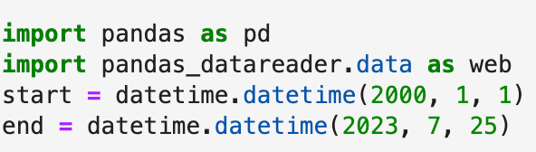

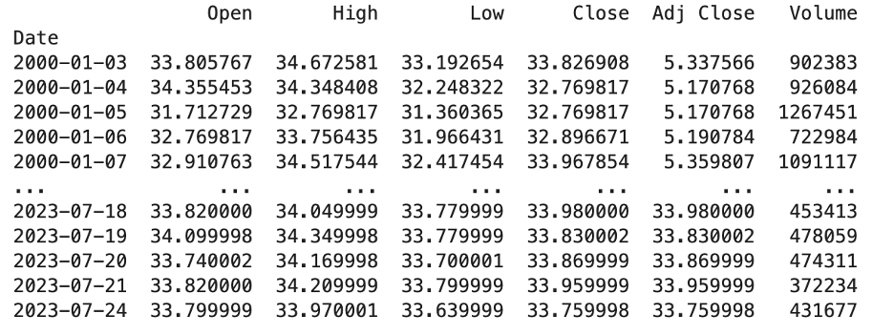

**Competitor Index**

| Relative Strength Index (14d) | |
| --- | --- |
| Accor SA | 55.53 |
| InterContinental Hotels Group PLC | 59.62 |
| Marriott International | 44.68 |
| Hilton Worldwide Holdings Inc. | 60.24 |
| Wyndham Hotels & Resorts, Inc. | 58.4 |

The Relative Strength Index (RSI) is a momentum oscillator that measures the speed and change of price movements. I am using the most popular implementation of RSI, which looks at a 14-day timeframe (as of July 27, 2023). Index scores range from 0 to 100, where a stock is considered overbought when the index is above 70 and oversold when below 30. Accor SA, with a Relative Strength Index (RSI) of 55.53, appears to be exhibiting moderate price momentum over the past 14 days, indicating a more balanced price movement. InterContinental Hotels Group PLC stands at 59.62, Marriott International records 44.68, Hilton Worldwide Holdings Inc. has an RSI of 60.24, and Wyndham Hotels & Resorts, Inc. sits at 58.4. Based on these values, it seems that Hilton Worldwide Holdings Inc. and InterContinental Hotels Group PLC have relatively stronger price momentum compared to the other companies, while Marriott International indicates relatively weaker price momentum. Accor falls in the middle.

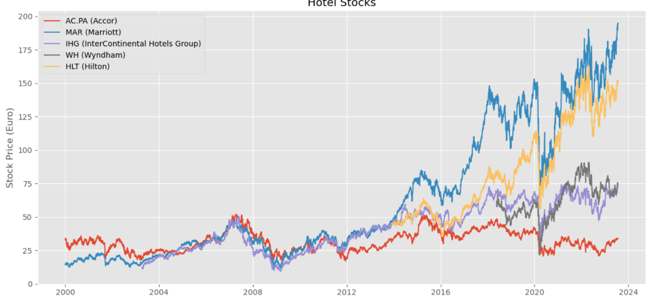

Using Python, the graph analyzed the stock prices of Accor and compared them with those of InterContinental Hotels Group PLC, Marriott International, Hilton Worldwide Holdings Inc., and Wyndham Hotels & Resorts. Until 2012, Accor consistently demonstrated a better stock price performance than the other hotel companies. However, from that point onward, all the hotels experienced growth. Despite being stable with only minor fluctuations, Accor's stock price didn't see significant increases, especially after 2016. On the other hand, other companies, particularly Marriott Hotels, displayed greater growth but also more substantial fluctuations. Since 2012, Accor has consistently maintained the lowest stock price among other hotels.

**Industry Index**

Analyzing Accor's performance in relation to the Industry Index over the past year offers valuable insights into how Accor has fared when compared to the performance of the hotel industry and various other sectors in France, the US, and Europe.

CAC 40 Index

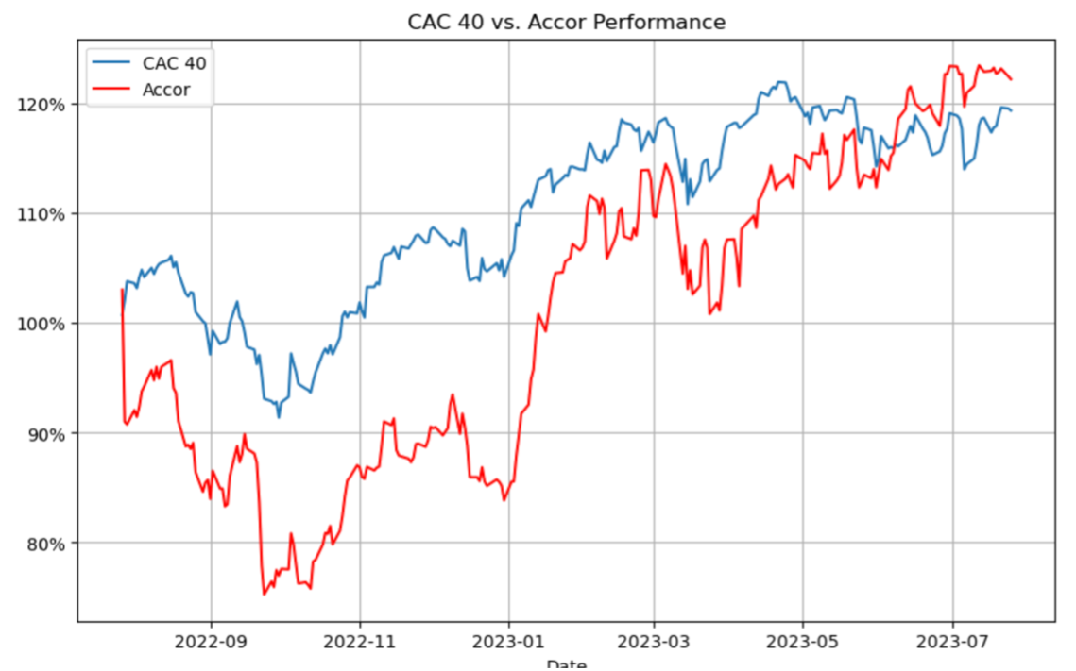

CAC 40 represents the 40 largest and most actively traded companies listed on Euronext Paris, the French stock exchange. When comparing Accor to the CAC 40, Accor had experienced larger fluctuations than the index. Before June, Accor had consistently performed below the index, but it surpassed the index after June.

Europe Hospitality, Travel, and Leisure Industry

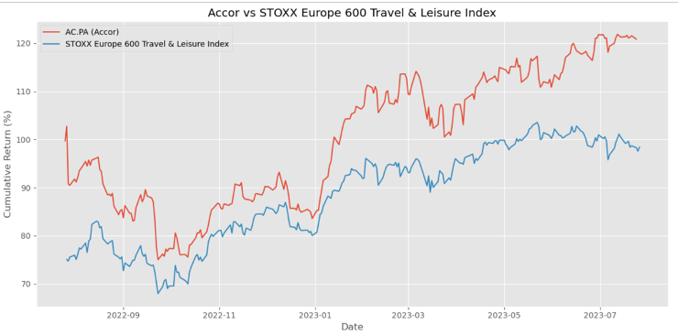

STOXX Europe 600 Travel and Leisure Index tracks companies engaged in the travel and leisure industry, including airlines, hotels, restaurants and travel agencies from 17 European countries. Accor is one of the company in there, weighted 0.11%. The data images of the STOXX Europe 600 Travel and Leisure Index and Accor were obtained and compared. The analysis reveals that the STOXX Europe 600 Travel and Leisure Index exhibited relatively smaller fluctuations compared to Accor. Before 2023, the gap between the index and Accor was smaller than after 2023, with Accor consistently surpassing the index.

US Hotel Industry

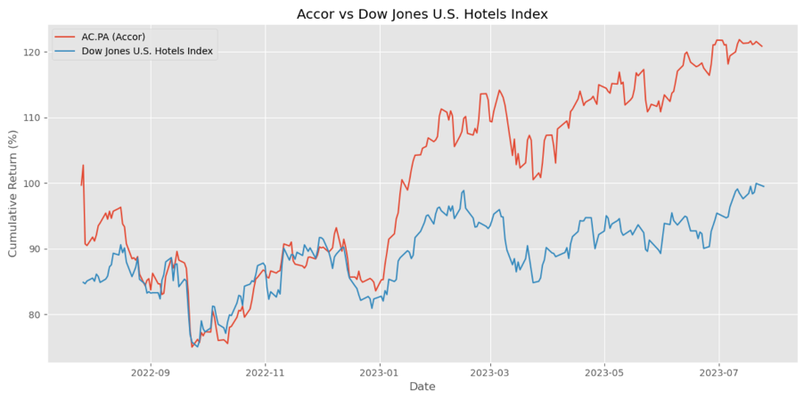

The Dow Jones US Hotel Index specifically focuses on companies within the hotel sector, such as hotel chains, resorts, operating in the United States. The data images of the Dow Jones US Hotel Index and Accor were obtained and compared. The analysis reveals that both experienced significant fluctuations, but Accor's fluctuations were more pronounced. Prior to 2023, the lines overlapped for the most part. However, after 2023, Accor's value increased and consistently remained higher than the index. While the index showed more stability, Accor's performance remained volatile.

**Comparative Index Analysis S&P 500:**

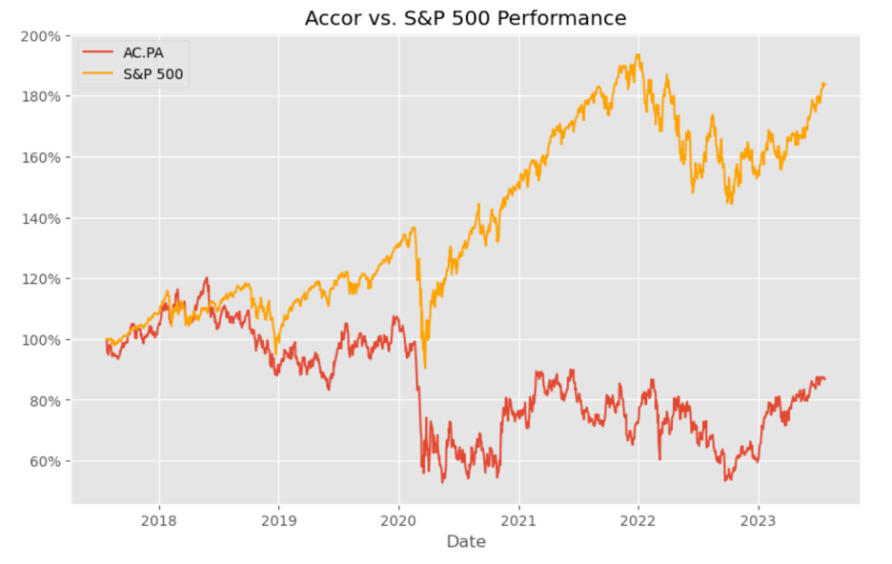

Using the Python drawing tool, data image of the S&P 500 and Accor stock prices is obtained.

The S&P 500 is the index that tracks the performance of 500 large companies listed on U.S. stock exchanges. It is a benchmark for the overall performance of the U.S. stock market. To attain a more comprehensive outlook, delving into 5-year stock price data provides an extended perspective, facilitating a deeper comprehension of trends, patterns, and potential cyclical fluctuations within the market.

Between 2017 and 2021, Accor and the S&P 500 exhibited distinct trajectories in their stock prices. The S&P 500 index demonstrated remarkable gains, reaching new all-time highs multiple times. On the other hand, Accor's stock price experienced a more mixed performance, influenced by the volatility in the travel and tourism industry due to geopolitical events, global economic fluctuations, and the devastating impact of the COVID-19 pandemic on the hospitality sector. While Accor did witness periods of growth and recovery, it also encountered significant challenges, leading to fluctuations and declines in its stock price. Since 2021, Accor has maintained a lower position with relatively minor fluctuations, while the S&P 500 started to rise and has consistently remained higher than Accor until the present time.

# Market Research

**What type of marketing does the company do to increase their brand recognition?**

**Digital Marketing:** The company uses digital marketing to reach a broader audience. They run targeted online advertising campaigns on social media platforms like Facebook, Instagram, Twitter, and search engines like Google Ads. Accor produces blog posts, articles, videos, that highlight unique experiences offered by their brands and destinations. Display networks are also used to showcase various brands, promotions, and offerings, thereby increasing brand visibility and attracting potential customers. The company also collaborates with social media influencers and travel bloggers to leverage influencer marketing. These influencers share their experiences and stays at Accor properties, reaching their followers and potential customers. Endorsements and positive reviews from influencers increase brand credibility and awareness, especially among younger audiences.

**Loyalty Program - ALL:** AccorHotels' loyalty program, ALL - Accor Live Limitless, is a crucial tool for customer engagement and brand recognition. They use targeted marketing communications to promote the benefits and value of the loyalty program. By offering personalized offers, rewards, and exclusive experiences, the company encourages customer retention and loyalty, ultimately boosting brand recognition.

**Partnerships:** AccorHotels forms partnerships with travel agencies, online travel platforms, and lifestyle brands to increase brand exposure. Collaborations with these partners provide access to their customer base and showcase Accor's offerings to a broader audience, thus increasing brand recognition.

**Event Sponsorships:** Accor participates in and sponsors various events, conferences, and cultural activities to enhance brand recognition and association. Associating with high-profile events and collaborations helps boost brand visibility and establishes Accor as a prominent player in the hospitality industry.

**CSR and Sustainability Marketing:** The company emphasizes its commitment to sustainability and corporate social responsibility (CSR) initiatives in its marketing efforts. By promoting its eco-friendly practices, social contributions, and sustainable initiatives, Accor appeals to conscious consumers who prioritize responsible and ethical brands.

**Brand positioning**

**Marketshare:** The market share of Accor, a European hospitality giant, is supported by several factors that position it for potential growth. Firstly, Accor's strong positioning in the global hotel sector is a key asset, with the company currently holding the sixth position worldwide and leading the sector in Europe. In Europe and outside of France, Accor holds over 40% of the market share, while in France, it holds a third of the market share. This extensive market presence is further strengthened by Accor's diverse portfolio of brands, catering to different socio-economic levels, ranging from luxury to mid-range and economical segments.

**Company Rankings from Industry Organizations:** AccorHotels holds a strong brand positioning in the global hotel industry, boasting a substantial presence across 110 countries with 5,445 hotels and 802,269 rooms. Its diverse brand portfolio caters to various customer segments, from luxury to economy travelers, ensuring widespread appeal. The company's focus on personalized guest experiences and augmented hospitality fosters brand loyalty and retention. Operating under an asset-light model has led to solid financial performance and continuous growth. Additionally, AccorHotels' commitment to sustainability and proactive expansion through acquisitions and strategic initiatives further strengthens its market position. Overall, these factors contribute to its recognition as a major player in the industry.

**Franchise**

Another significant aspect of Accor is its strategic focus on franchising as its business model. Franchise agreements are contracts whereby Accor offers hotel owners access to a brand, as well as distribution, sales, marketing, and loyalty services. Franchised hotels are operated by their owners under an Accor brand. The Group provides access to various services, mainly granting the right to use its well-known hotel brands, such as Novotel, Ibis, Ibis Styles, Ibis Budget, Mercure, Pullman, Sofitel, Adagio, Mama Shelter, Swissotel, Raffles, Fairmont, Rixos Hotels, MGallery, and Banyan Tree. Additionally, the hotel owners gain access to Accor's distribution system and can avail additional services, including centralized purchases and training for hotel staff through the Accor Academy.

To expand its global presence through franchise agreements, Accor collaborates with various partners around the world. These partners include Sunmei Digital Intelligence Group in China, Salter Brothers in Australia, Twenty 14 Holding in Dubai, Khaolak Inter in Thailand, Alcon Victor Group in India, and Groupe ADP in France. The revenue generated by Accor corresponds to the fees invoiced to the hotel owners. These fees may include trademark fees, distribution and marketing fees, and charges for any additional services utilized by the owners. Through this strategic approach, Accor can bring its renowned hotel brands to new markets and regions while leveraging the resources and expertise of its partners.

# SWOT Analysis

**Strengths**

**Global Presence:** AccorHotels is uniquely positioned in the global hotel market, with 5,445 hotels and 802,269 rooms in more than 110 countries. An established presence across several countries lends AccorHotels with significant level of brand awareness, which, in turn, helps the group to expand its operations in new markets and increase access to lucrative markets.

**Diverse Brand Portfolio:** The company's comprehensive brand portfolio, with each brand offering its own service range, pricing strategy, and unique brand image, serves multiple customer segments and provides various revenue streams for the group. This diversity effectively mitigates the risk of relying heavily on one specific market segment, ensuring AccorHotels' ability to capture a wide range of travelers with varying preferences and budget levels.

**Solvency Position:** Strong solvency position indicates utilization of lower financial leverage and its comparatively higher equity position, underlining the better creditworthiness of the group. The group recorded a debt-to-equity ratio of 0.65 at the end of FY2022, as compared to 0.82 in the previous year. In FY2022, the group recorded total equity of EUR5,059 million, an increase of 18.1% over the previous year. It reported total debt of EUR3,316 million compared to EUR3,526 million in the previous year.

**Augmented Hospitality:** The emphasis on offering personalized and unique guest experiences through augmented hospitality sets AccorHotels apart from competitors. The ALL loyalty program further strengthens customer relationships and builds loyalty.

**Strategic Initiatives:** The company actively pursues strategic initiatives through partnerships and acquisitions, expanding its business and accessing new customer markets. This diversification adds value to its offerings and revenue streams.

**Weaknesses**

**Financial Performance**: In FY2022, the group experienced a decline in cost efficiency, with operating expenses as a percentage of revenue rising to 87.93% from 85.44% the previous year. This increase was driven by a significant rise in operating expenses (97.2% increase to EUR 3,714 million) compared to a growth in revenue (91.7% increase to EUR 4,224 million). As of December 31, 2022, 97% of the group's bonds and bank borrowing were at a fixed rate, with an average rate of 2.1%, while 3% were at a variable rate, with an average of 5%. The fixed rate debt is primarily denominated in euros. Fluctuations in interest rates can impact customer behavior and hinder Accor's expansion. Additionally, if the euro appreciates, revenue may decrease when converting currencies for financial reporting, potentially affecting Accor's competitiveness. The company faces liquidity risk, but it has one undrawn confirmed credit line for €1,200 million maturing in June 2024 (€86 million) and in June 2025 (€1,114 million). Liquidity risk may arise from fluctuations in revenue, changes in economic conditions, and unexpected events.

**Pandemic Impact:** The ongoing global pandemic has significantly affected the hotel industry, including AccorHotels. Uncertainties surrounding travel patterns and restrictions continue to pose challenges for the company's operations and financial performance.

**Online Travel Agencies:** Reliance on online travel agencies for bookings exposes AccorHotels to commission fees and potential revenue loss if traffic is diverted to competitors' properties.

**Opportunities**

**Growth in Luxury and Upscale Segments:** AccorHotels' strong presence in the luxury and upscale segments positions it well to benefit from the increasing demand for premium experiences among travelers worldwide.

**Opportunities in China:** Strengthening its presence in China and catering to Chinese tourists' preferences allows AccorHotels to tap into the world's largest source market for tourism.

**Strategic Initiatives and Partnerships:** AccorHotels is actively pursuing strategic initiatives and partnerships with companies like Traveloka to acquire new customers and enhance the customer experience. For instance, the partnership with Traveloka, Southeast Asia's lifestyle superapp, established in April 2022, allows guests to access Accor properties in 13 countries through Traveloka's platform.

**Business Expansion and Acquisitions:** AccorHotels is actively expanding its business through the opening of new hotels in promising locations, presenting opportunities to enter new markets, attract a broader customer base, and enhance brand recognition. In May 2023, the company partnered with Polski Holding Hotelowy Group to expand hotel development in Poland. In April 2023 AccorHotels entered into a partnership with Mambano Hotels Limited to open its first hotel in Zimbabwe. Additionally, the company has strategic plans to open hotels in Western Sydney, New Zealand, Georgia, and Shenzhen, China. These expansion initiatives signify the company's commitment to growth and its strategic approach to establishing a stronger presence in various regions.

**Accommodation Sector in France:** The group could benefit from the growing accommodation sector in France. According to an in-house report, the revenue of budget hotels in France is expected to reach US$8.42 billion, and their room occupancy rate is expected to grow to 58.19% by FY2025. The revenue from midscale hotels is expected to increase to US$11.86 billion and their room occupancy rate is expected to grow to 62.17% by FY2025. The revenue from upscale hotels is also expected to increase to US$13.63 billion and the average revenue per available room to US$171.64 by FY2025. The revenue from luxury hotels and their occupancy rate are expected to reach US$5.34 billion and 67.13%, respectively, by 2025. The growth in all hotel categories is expected due to an increase in leisure and business travel in France.

**Threats**

**Stiff Competition**: The company faces stiff competition from various restaurant operators in France. The lodging industry in France is highly fragmented with the presence of many independent operators, and small and large hotel and resort operators. The group operates in the hotels and resorts industry. The company’s competitors in this segment include Choice Hotels International Inc, Hilton Worldwide Holdings Inc, Marriott International Inc, Travel + Leisure Co, and NH Hotel Group SA. A broad network and a strong financial arm of these hotel chains pose a challenge to the company. An increase in marketing and promotional activities by competitors will likely exert pressure on the company, compelling it to find innovative ways to retain its market share.

**Online Theft and Hacking:** The group uses information technology in its various business transactions such as management software, stock system, accounting software, online booking engines, email, internet, which poses significant risks from online identity theft and hacking. The extent of Internet security at AccorHotels is dependent upon the quality of the hardware and software utilized, which may not protect its portal from unauthorized attacks resulting in break-ins and other disruptions system failures. These security breaches may threaten the security of data stored by AccorHotels within the scope of its services and their transmission by these computer systems.

**Risks Related to Competitive Brandjacking:** Competitive brandjacking could affect the performance of hotel operators such as the group. Competitive brandjacking includes the illegal use of popular brands by brandjackers to divert traffic to their sites without the permission of brand owners. The branded hotel industry worldwide incurs significant losses every year due to brandjacking, related to inflated or unnecessary payments of commissions and loss of online traffic to competitors. The major hotel brands face considerable risk of potential diversion of their search traffic with online travel agencies diverting them to competitors’ properties. Suggestions for other hotels in the area or hotels in the similar price range are likely to use the reputation of the major competitors in the region. Such diversion of search traffic could lead to loss of customers and revenue to their competitors or unnecessary payment of commissions. The increase in such practices is likely to pose a major challenge to the company, which affects its revenue and income.

**Regulatory Environment:** The hotel industry is subject to various regulations and licensing requirements in different countries. Changes in regulations, tax policies, or labor laws may increase operational costs and administrative burden for AccorHotels.

**Economic and Geopolitical Factors:** Economic downturns, political instability, and geopolitical tensions can impact travel patterns and reduce demand for hospitality services. Unfavorable economic conditions or political events in specific regions where AccorHotels operates may affect its operations and revenue.

**Dependency on Tourism:** AccorHotels' business heavily relies on the tourism industry. Any disruptions or changes in travel patterns, such as travel restrictions, health crises, natural disasters, or terrorist attacks, can negatively affect the company's operations and financial performance.

# Mergers and Acquisitions

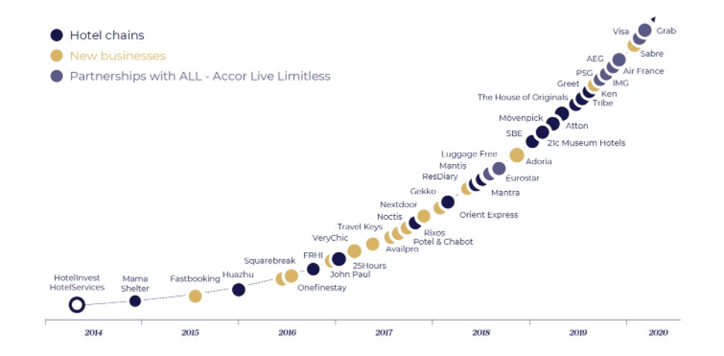

**M&A Overview**

Accor has made a total of 30 diverse acquisitions to expand its presence in various markets. Accor's mergers and acquisitions (M&A) strategy has been marked by a series of strategic moves that have significantly expanded its global footprint and diversified its portfolio across various locations and industry niches. The M&A activities can be categorized into both vertical and horizontal integrations, enabling Accor to solidify its position as a leading player in the global hospitality industry. The company has made significant acquisitions in countries like France, United States, Poland, Australia, New Zealand, Switzerland, United Kingdom, South Africa, Turkey, Indonesia, Canada, and Brazil.

In terms of vertical integration, Accor has made several strategic moves to strengthen its position in the luxury hotel segment. The acquisitions of Orient Express SAS, Mövenpick Hotels & Resorts, and FRHI Holdings (inculding its prestigious luxury hotel brands, including Fairmont, Raffles, and Swissotel.) have allowed Accor to enhance its portfolio of upscale properties in Paris, Switzerland, and Canada, respectively. These transactions have not only expanded Accor's luxury offerings but also provided opportunities for synergy with its loyalty program, distribution channels, and operating systems, driving growth in key markets. In the upscale hospitality and entertainment industry, Accor ventured further with the acquisition of SBE Entertainment Group and bolstered its boutique and art-driven hospitality with 21c Museum Hotels.

In terms of horizontal integration, Accor has strategically strengthened its digital services for the hospitality sector through acquisitions like Adoria, Availpro, and ResDiary. The company expanded its digital solutions by acquiring VeryChic and FastBooking, enhancing its presence in the serviced home rental and concierge services with onefinestay and John Paul. Additionally, Accor made strategic moves in the restaurant and dining sector with acquisitions like Potel & Chabot and Courtepaille. The company also consolidated its presence in the hospitality and travel vouchers and cards industry with acquisitions like Kadéos, PrePay Technologies Ltd., SurfGold, and Commuter Check Services Corporation. Accor's budget motels and hospitality chain were strengthened through the acquisition of Motel 6, while the 3-star hotel chain Mercure also became part of the group. Lastly, Accor entered the casino and gaming industry with the acquisition of SPIC.

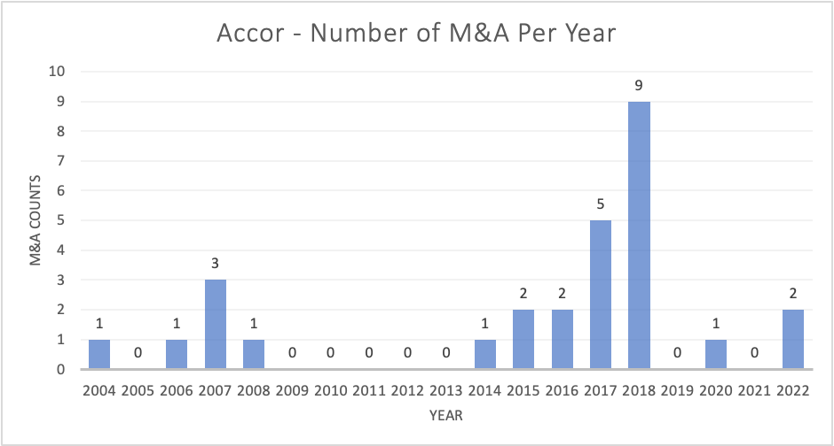

Accor's M&A activities have displayed an interesting pattern over the years, as depicted in the bar-plot. From 2004 to 2008, there were a few acquisitions, followed by a relatively quiet period until 2013. However, starting in 2014, there was a notable increase in M&A activity, with a peak in 2018 with nine deals. In the following years, M&A activity displayed variability, with some years recording no deals, while others saw one or two deals being executed. Digging into the year 2018 with nine deals, it becomes evident that Accor was actively engaging in strategic acquisitions during this period.

During the period from 2017 to 2019, Accor's long-term financial debt remained relatively stable, showing no significant changes. Interestingly, their cash reserves experienced a substantial increase from 1,063 million to 2,820 million between 2017 and 2018. This sudden rise in cash coincided with a significant decrease in assets held for sale, dropping from 4,824 million to 14 million during the same period. This suggests that the surge in cash was likely achieved through the strategic selling of assets. Such a move might have contributed to the increase in M&A activity during those years. As a result, the increased cash reserves could have provided Accor with the financial strength and flexibility to pursue multiple M&A deals in 2018, thereby contributing to the peak in their M&A activity during that period.

After COVID-19, the overall capital management of Accor appears to be healthy. The debt-to-equity ratio has been fluctuating between 0.8 to 1.4, which is a common range for companies in the hospitality industry. Despite financing some M&A deals through debts, Accor's M&A activity has remained within their financial capacity. Although M&A can create value, it also presents integration challenges, such as merging corporate cultures and operational systems. Smooth integration is crucial to realizing the full potential of acquired assets and synergies.

Accor's total assets consistently increased, partly due to M&A deals, as seen from €12.9 billion in 2018 to €11.7 billion in 2022. Fluctuations in "Goodwill" and "Other intangible assets" over the years are expected as they are influenced by M&A activities. For instance, the rise in "Goodwill" from €1.995 billion in 2019 to €2.282 billion in 2022 indicates premiums paid over the fair value of acquired businesses in some deals. Additionally, the "Net profit of the year" has shown significant fluctuations over time, with negative results in 2020 and positive results in subsequent years. These fluctuations can be influenced by M&A activities due to acquisition-related costs and potential synergies realized post-acquisition. Overall, while M&A can be beneficial, it requires careful consideration and strategic management to yield the desired outcomes.

Here are the details of each M&As:

1. In May 2017, Accor SA acquired Paris Society, a company that has become a leader in events, hospitality, and entertainment in France over the past decade. Accor initially purchased a 48.14% stake in the company in February 2022 and later increased its ownership to 95% through further acquisitions in November 2022. Paris Society's upscale collection of restaurants and entertainment venues, with iconic addresses such as Apicius, Terminal 7, and Le Rooftop, strengthened Accor's position in the high-end catering and event management market.

2. In 2017, AccorHotels acquired a 50% stake in the iconic Orient Express brand from SNCF Group, the French rail operator, for 24.4 million euros. This partnership aimed to develop luxury hotels under the Orient Express banner, with planned locations in Rome, Venice, London, Istanbul, Paris, and Riyadh. Additionally, AccorHotels announced the launch of Orient Express Silenseas, a luxury sailing ship with 54 suites and a revolutionary design called SolidSail, intended to be the world's largest sailing ship when it debuts in 2026. In June 2022, Accor SA acquired the remaining 50% stake in Orient Express for 19 million euros, bringing its ownership to 100% (a total of 43.4 million euros). This acquisition allows Accor to have full control over the development of the iconic Orient Express brand. The company's goal is to create a captivating journey of luxury and refinement by transporting the heritage of the legendary Orient Express train to a collection of Orient Express hotels. By 2030, Accor aims to have a network of 10 Orient Express addresses, further strengthening its luxury segment and presence in the luxury travel market. Recently, the company signed a partnership to open the second Orient Express hotel in Venice, Italy.

3. In October 2018, the company acquired a 50% stake in Sbe Entertainment for 271.5 million. In 2020, SBE Entertainment Group, a US-based company, acquired full ownership of SBE Entertainment from Sam Nazarian by purchasing the remaining 50% stake at a deal price of 41 million euro (total of 312.5 million). Additionally, SBE Hotels was acquired as part of Accor's growth strategy focused on acquiring hotel chains. The merger of Ennismore and SBE created a new group with 13 global brands, 73 hotels, and over 150 bars and restaurants, becoming a major source of future growth for Accor.

4. Accor acquired 33.1% of Orbis, the leading hotel group in Central Europe, for €339 million, increasing its stake to 85.8%. This move allowed Accor to strengthen its presence in key hospitality markets and integrate Orbis hotels into its global network, offering enhanced services to customers and loyalty program members. The transaction aligned with Accor's asset-light strategy and facilitated a significant expansion in Eastern Europe. The Orbis acquisition solidified Accor's leadership in Central Europe, making it the top hotel group in the region and further advancing its growth strategy.

5. In September 2018, AccorHotels acquired 85% of 21c Museum Hotels for 46 million eruo. 21c Museum Hotels, known for combining contemporary art museums, boutique hotels, and restaurants, joined Accor's MGallery collection, making its debut in the North American market. This acquisition expanded Accor's portfolio and enhanced its offerings with unique, art-driven hospitality experiences across the United States.

6. AccorHotel acquired Adoria, a SaaS platform that optimizes supply management in the catering industry. With this acquisition, AccorHotel continues to diversify its activities by adding new distribution channels. Adoria's platform connects all players along the food and beverage supply chain, providing centralized solutions for tendering, procurement, logistics, and production. The acquisition strengthens Accor's digital services and expands its offerings to restaurant owners, allowing them to optimize table management and procurement. Adoria's significant activity metrics include 65,000 references in the catalogue, over 100,000 monthly orders. This move enhances AccorHotel's presence in the hospitality industry and reinforces its commitment to offering comprehensive solutions to its customers.

7. On May 31, 2018, AccorHotels successfully completed the acquisition of Mantra Group for AU$1.3 billion (€830 million), solidifying AccorHotels as the sole shareholder of Mantra. The deal included 127 properties with over 20,000 rooms in hotels, resorts, and serviced apartments spread across Australia, New Zealand, Indonesia, and Hawaii. Mantra is one of Australia's largest hotel and resort marketers and operators, known for its Peppers, Mantra, and BreakFree brands. With this acquisition, AccorHotels, renowned for hotel-style accommodations under brands like Sofitel, Novotel, Mercure, and ibis, now incorporates Mantra's expertise in the serviced apartment sector. This strategic move further strengthens Accor's position in the Asia Pacific region, as the company now operates over 330 hotels and resorts across Australia and more than 900 throughout the region. The acquisition opens up new growth opportunities and enhances AccorHotels' presence in the serviced accommodation sector, bringing together complementary offerings under one unified umbrella.

8. On April 30, 2018, Accor SA acquired Movenpick Hotels & Resorts for €482 million. This acquisition was significant for Accor as it reinforced the company's position in the premium hotel segment in Europe and the Middle East. Movenpick Hotels & Resorts, founded in Switzerland in 1973, operated in 27 countries with 84 hotels and more than 20,000 rooms. The deal allowed Accor to expand its presence in key regions and accelerate growth, benefiting from Movenpick's strong presence in Europe, the Middle East, and their plans to open 42 additional hotels. The acquisition also provided opportunities for synergy with Accor's loyalty program, distribution channels, and operating systems. The transaction had a positive impact on Group earnings from 2019. Overall, the acquisition of Movenpick Hotels & Resorts played a crucial role in strengthening Accor's position in the global hospitality industry and driving growth in key markets. Additionally, on September 3, 2018, Accor acquired an additional 33.33% stake in Movenpick Hotels & Resorts for €169.8 million, further consolidating its leadership in the European market and expanding in emerging markets, particularly in the Middle East, Africa, and Asia-Pacific.

9. Accor completed the acquisition of ResDiary, a renowned restaurant reservation and table management platform based in Glasgow. The deal aimed to expand Accor's digital services and diversify its distribution channels, attracting new customers in the hospitality industry. ResDiary offered commission-free, high-end table management services, empowering restaurant owners to optimize revenue and control operational costs effectively. With a presence in 60 countries and seating approximately 166 million diners annually in over 8,600 venues, ResDiary provided Accor with a valuable platform to enhance its services and improve the guest experience. This acquisition complemented Accor's strategy of increasing points of contact with a growing customer base and aligning with its goal of offering digital solutions for hotel and restaurant operators.

10. Accor acquired a 50% stake in the Mantis Group, a South Africa-based hospitality and travel conglomerate, which reinforced its presence in the luxury segment in Africa. Mantis is known for its collection of extraordinary destinations on seven continents, offering unique and exceptional settings for travelers. The partnership allowed Accor to expand its portfolio with 29 hotels (578 rooms) in 11 countries and 321 rooms in development. This move enhanced Accor's position in Africa's hospitality market and leveraged Mantis' reputation for environmentally-conscious practices and excellence in the hospitality sector.

11. AccorHotels announced the acquisition of 89.1% of the share capital and voting rights of Gekko for €96 million. The strategic move aimed to consolidate AccorHotels' position as a leading provider of hotel reservation platforms in Europe. Gekko, with its expertise and state-of-the-art technology, offers search and reservation solutions to more than 500,000 hotels worldwide. With the completion of this acquisition, AccorHotels expanded its reach to serve over 300 corporate customers and 14,000 travel agencies, further reinforcing its commitment to enhancing the customer experience in the business travel segment.

12. AccorHotels acquired over 50% of the share capital, integrating 15 iconic Rixos Hotels into its network. The collaboration allowed AccorHotels to offer attractive leisure destinations and enhance its brand portfolio. Rixos Hotels' renowned Turkish hospitality, unique spa experiences, and luxury atmosphere complemented AccorHotels' offerings, contributing to its global growth strategy.

13. AccorHotels announced the acquisition of 83.3% of the share capital and voting rights of Availpro. Created in 2001, Availpro is a leader in France and one of the leading European software providers to hoteliers, serving over 6,500 clients. Following the acquisition of Fastbooking in 2015, this strategic move allowed AccorHotels to consolidate its digital services division for independent hotels and round out Fastbooking's range of services. By combining the expertise of Availpro and Fastbooking, AccorHotels became the leading European digital services provider for independent hotels, offering a comprehensive suite of innovative and high-performance applications to enhance their online visibility and sales. The acquisition price was €24 million, and AccorHotels committed to acquire the remaining shares in two tranches in April 2018 and April 2019 at a total price of €5 million.

14. In March 27, 2017, AccorHotels agreed to acquire a 100% stake in Potel & Chabot, a renowned brand known for reinventing the art of fine dining since 1820. Potel & Chabot specialized in organizing tailor-made prestige receptions and was a leading player in the luxury and premium segments. Its offerings included receptions for large companies and private customers, exclusive management of unique reception venues in central Paris, and major sporting, industrial, and cultural events. AccorHotels planned to leverage Potel & Chabot's expertise to develop innovative and refined food and beverage solutions for its hotel guests, private residences, and local residents seeking personalized concierge services. This strategic move allowed AccorHotels to expand its portfolio and capitalize on new growth opportunities and value-creation drivers in the hospitality industry. In May 17, 2017, AccorHotels finalized the acquisition of a 39.5% stake in Potel & Chabot Group through a consortium. With this transaction, the group gained significant influence over Potel & Chabot and its development prospects. The brand's long history and reputation for excellence further enriched the diverse ecosystem of hospitality services offered by AccorHotels, fostering new growth prospects for the company and its partners.

15. AccorHotels acquired 75% of the share capital and voting rights of VeryChic, a digital platform for the private sale of luxury hotel rooms, apartments, cruises, breaks, and packages. With 7 million members worldwide, VeryChic offers exclusive deals in exceptional hotels, with discounts of up to 70%. More than 4,000 partner hotels optimize their distribution through VeryChic's private sales, catering to a member base of over 5 million. The acquisition price amounted to €22 million. This strategic move aimed to strengthen AccorHotels' expertise in creating exceptional private sales and to accelerate VeryChic's international development, aiming to become the world leader in its sector. The remaining 25% of VeryChic's capital is retained by the selling shareholders, with a put option exercisable in two tranches in 2019 and 2020.

16. On July 27, 2016, AccorHotels acquired John Paul, the world leader in concierge services, for €309 million. This acquisition was crucial for AccorHotels as it aimed to expand service offerings, enhance customer relations expertise, and diversify its business model. With 700 concierges and a digital platform, John Paul provided loyalty solutions for customers and employees of businesses and brands. The acquisition also supported the rollout of AccorLocal in France, extending services to local residents. By leveraging John Paul's expertise, AccorHotels consolidated its leadership in the luxury private rentals market and offered comprehensive loyalty solutions across industries, generating new service revenues. Overall, the acquisition played a critical role in transforming AccorHotels' business model.

17. AccorHotels acquired onefinestay, a leading luxury serviced home rental brand, for €148 million. onefinestay manages a portfolio of 2,600 exclusive homes in prime locations like London, New York, Paris, Los Angeles, and Rome. The acquisition allowed AccorHotels to expand its service offerings, providing customers with the luxury of a private apartment while enjoying hotel-like services. This strategic acquisition allowed AccorHotels to expand its service offerings to customers who prefer the luxury experience of the Group's hotels but seek the comfort and uniqueness of a private apartment. onefinestay became the world's leading luxury serviced home rental brand, closely aligned with AccorHotels' luxury hotel operations. The acquisition of onefinestay further solidified AccorHotels' position in the luxury serviced homes market and offered customers a new and unique option to enjoy the Group's exceptional service in a different environment.

18. In July 2016, AccorHotels completed the acquisition of Fairmont Raffles Hotels International (FRHI) and its prestigious luxury hotel brands, including Fairmont, Raffles, and Swissotel. The deal was valued at approximately $2.9 billion USD. This acquisition strengthened AccorHotels' position in the global luxury hotel market, giving it a portfolio of 154 new luxury hotels, with 40 more in the pipeline. It also expanded the Group's presence in North America, a critical market for the luxury segment. Prior to the acquisition, AccorHotels' primary luxury brand was Sofitel. The acquisition contributed to a significant increase in AccorHotels' fees collected from the luxury segment, and it accounted for 35% of HotelServices management fees. This strategic move enhanced AccorHotels' brand portfolio, geographical diversification, and long-term growth potential. With this expansion, AccorHotels solidified its position as one of the best global players in the luxury hotel segment, bolstering its international reach and profitability.

In terms of the financial aspects, AccorHotels paid $840 million in cash and issued 46.7 million Accor shares to the former owners of FRHI. Qatar Investment Authority and Kingdom Holding Company of Saudi Arabia became major shareholders in AccorHotels, holding 10.5% and 5.8% of the share capital, respectively. Following the acquisition, AccorHotels formed a standalone Luxury Brand group within its organization, which included the brands Raffles, Fairmont, Sofitel Legend, So Sofitel, Sofitel, MGallery by Sofitel, Pullman, and Swiss‚àö¬•tel. Chris Cahill, who had previously served as the president and COO of FRHI, was appointed as the CEO of luxury brands to lead the integration process. AccorHotels anticipated generating approximately‚ 65 million euro in revenue and cost synergies through brand combination, maximizing hotel earnings, improving marketing and distribution channel efficiency, and optimizing support costs. Additionally, the integration of FRHI's customer base of 3 million loyalty members, primarily from North America, was expected to enhance customer data and provide cross-selling opportunities.

19. AccorHotels acquired 100% of the share capital of FastBooking for €1.8 million as part of the Group's €225 million investment plan. The plan was aimed at incorporating digital technology throughout the customer journey and improving services for investor partners, as well as consolidating the Group's distribution market share. The acquisition of FastBooking played a crucial role in this digital transformation strategy, allowing AccorHotels to provide cutting-edge digital services and enhance its distribution platform. The integration of FastBooking and the overall digital transformation plan are vital components of AccorHotels' ongoing efforts to strengthen its position in the highly competitive hospitality industry.

20. Accor acquired a 36.6% stake in the hotel company Mama Shelter. Over the years, Accor gradually increased its ownership and on May 4, 2021, acquired the remaining 30% stake for €30 million, bringing its ownership to 100% of the company. The total consideration for the acquisition amounted to €78 million. Mama Works, a part of Mama Shelter, provides a vibrant and flexible space for collaboration and creativity, serving as a meeting point for various professionals, from CEOs to entrepreneurs and freelancers. Currently, Mama Shelter operates three spaces totaling 6,495 sq.m in Lille, Lyon, and Bordeaux, with two more spaces covering 3,800 sq.m under development.

21. Accor Services acquired a 62% stake in Motivano UK, a prominent online provider of flexible benefits, total reward statements, and voluntary benefits solutions. The acquisition included the purchase of the 64% interest previously held by venture capital firm GeoCapital Partners. As a result of the deal, Motivano UK's current management team retained a 36% interest in the company. The acquisition, which amounted to €6 million in cash, aimed to strengthen Accor Services' position as a leading provider of employee and constituent benefits solutions.

22. In September 2007, Accor Services made a significant move to bolster its technological innovation capabilities by acquiring a 98.3% stake in PrePay Technologies Ltd., the UK's leading provider of prepaid card solutions. The acquisition was valued at €63 million paid in cash. This strategic acquisition aimed to diversify Accor Services' portfolio of products and services in the UK and strengthen its position as a leader in the prepaid card market. PrePay Technologies specializes in managing real-time authorization platforms and is authorized to issue e-money, serving prominent British retail chains with reloadable cards available at over 30,000 top-up terminals.

23. Accor Services made a strategic move by acquiring a 98.3% stake in Kadeos, which was the gift card and voucher business of the PPR Group, for €206.4 million. This acquisition established Accor Services as the dominant player and leader in the French market for gift cards and vouchers. With this strategic move, Accor Services solidified its position and strengthened its portfolio of services in the gift card and voucher industry in France.

24. In June 2007, Accor SA acquired a 98.3% stake in SurfGold, a Singapore-based company specializing in loyalty and incentive solutions for companies' employees, partners, and customers. SurfGold had operations in several Asian countries, including China, South Korea, Hong Kong, India, Singapore, and Taiwan. The total purchase price for the acquisition was €9.3 million. This strategic move allowed Accor to expand its presence and offerings in the loyalty and incentive solutions market across the Asian region.

25. In March 2006, Accor Services further expanded its presence in the US market by acquiring Commuter Check Services Corporation, an American company issuing transit vouchers. This acquisition allowed companies to assist their employees in funding their daily commuting requirements. Commuter Check Services Corporation was a significant player in this market in the US, with a business volume of $79 million in 2005, around 3,700 customers, and 110,000 users in major American cities such as San Francisco Bay Area, Boston, and Philadelphia. The acquisition cost $35 million USD in cash.

26. Accor acquired all outstanding shares in Go Voyages, a travel and tourism company. The acquisition process began in 2000 when Accor initially purchased 38.5% of Go Voyages for €11.9 million. In 2002, an additional 21.5% of the company was acquired for €12.3 million, increasing Accor's interest to 60%. In 2003, Accor further increased its participation by 10% for €7.2 million, reaching a 70% stake in Go Voyages. Finally, in 2004, Accor acquired the remaining 30% of Go Voyages' capital for €22 million, resulting in full ownership of the company. This acquisition allowed Go Voyages to become a leading player in the travel and tourism market, particularly in the online space with innovative IT tools.

27. Accor acquired a majority interest in SPIC, which was subsequently renamed Accor Casinos. Accor's interest in Accor Casinos increased to 65%. This strategic move allowed Accor to enter the casino and gaming industry. Accor Casinos managed five establishments in France, including Ruhl, Cassis, Carry, and Chamonix Casinos.

28. Accor acquired the Motel 6 chain in the United States, comprising 550 properties, for approximately €1.1 billion. This acquisition made Accor the world's largest group of budget motels and established the company as the leading hotel group globally in terms of hotels directly owned or managed (excluding franchises). With the addition of Motel 6, Accor's portfolio expanded to more than 775 economy motels, and the company now operated over 850 hotels in 60 countries. On October, 2012, Accor completed the sale of its United States Economy Hotels Division, including Motel 6 and Studio 6, to an affiliate of Blackstone for $1.9 billion.

29. Acquisition of the 3-star chain, Mercure.

30. Acquisition of the Courtepaille restaurant chain.

**Investments**

**Investments Overview**

For investments, Accor has made 11 strategic investments, covering a diverse range of ventures such as Worklib, a flex office reservation platform; Treebo Hotels, a tech-enabled budget hotel chain; OnePark, a booking platform for parking services; Travelsify, offering personalized travel search experiences; Air France KLM, for airline partnerships; Huazhu Group Limited, expanding its presence in Chinese hospitality; Mindsay, utilizing conversational AI for customer service; Banyan Tree Hotels & Resort, strengthening its portfolio in the international hospitality industry; 25hours Hotels, for global expansion of boutique experiences; Oasis Collections, providing upscale property rentals with hotel services; and Squarebreak, offering private upscale properties with hotel-like services in resort locations.

Over the three-year period mentioned (2020 to 2022), the non-consolidated investments experienced fluctuations in value. The investments incurred losses in 2020 and 2021 but rebounded significantly in 2022, resulting in a noteworthy gain of 142 million. This indicates a certain level of volatility in the investment market during these years, which may have been influenced by various economic factors and market conditions or covid-19.

Here are the details of each investments:

1. Accor has co-invested with Bazeo Europe SAS in Worklib, securing 9.3 million in seed funding. The purpose of this investment is to develop and operate a flex office reservation platform. A Shareholders' Agreement was signed with Bazeo Europe SAS, Anima SAS, and Alexandre Cadain, Worklib's founding partners. Accor's initial stake in Worklib was 26.66%, increased to 40% on January 31, 2022. They invested a total of €2.4 million in cash for a share capital increase. The collaboration allows Accor to leverage AI expertise for a unique workspace distribution platform and accelerate its coworking development strategy in hotels and dedicated spaces.

2. Accor participated in Treebo Hotels' Series D funding round. The late-stage venture funding raised 13.8 million euros for Treebo, India's tech-enabled and asset-light affordable accommodation brand. Accor's investment in Treebo signifies the company's interest in supporting innovative and promising players in the hospitality industry. The partnership is expected to foster growth opportunities for Treebo and may also provide Accor with potential strategic benefits in the Indian market.

3. OnePark, a booking platform for parking spaces based in Paris, Ile-de-France, France, secured USD 15 million in a Series B funding round. The funding was aimed at supporting the company's expansion and strengthening its position as a key player in the parking services market. OnePark is part of Accor's ecosystem of service providers. This investment in OnePark was significant for Accor as it contributes to building a comprehensive and profitable ecosystem of services, ensuring an attractive and coherent range of offerings for their customers.

4. Accor participated in a venture funding round that raised €5 million for Travelsify in September 2018. Travelsify offers a Travel Product DNA platform that powers next-generation personalized search experiences. This investment demonstrates Accor's interest in innovative technologies and its commitment to enhancing the travel and hospitality industry through cutting-edge solutions.

5. Accor acquired a 14.3% stake in Air France-KLM through a Post-IPO Equity funding arrangement. This strategic move reflects Accor's interest in the aviation sector and aims to strengthen its portfolio while exploring potential synergies in the travel and hospitality industry. By investing in Air France-KLM, Accor seeks to enhance its presence and offerings in various segments of the travel market, creating new opportunities for collaboration and improving the overall travel experience for their customers.

6. Accor announced the acquisition of a 4.5% stake in Huazhu Group Limited, a Chinese hotel operator. Additionally, by the end of 2018, Accor's most significant strategic partnerships in terms of investment were with China Lodging Group (Huazhu Hotels), in which they held a 10.8% stake amounting to 935 million euro. These investments highlight Accor's focus on expanding its presence in the Chinese hospitality market and leveraging strategic partnerships to enhance its global portfolio.

7. Accor's investment in Mindsay's Seed funding round, with a contribution of €1.1 million, is indicative of their interest in cutting-edge technology and their commitment to providing exceptional customer service experiences. By supporting Mindsay, a conversational AI company, Accor aims to leverage AI-powered solutions to enhance their customer care services. Mindsay's technology enables companies, including Accor, to scale their one-to-one care interactions, offering personalized and efficient support to their customers.

8. The $14.3 million investment in Banyan Tree Hotels & Resorts' Post-IPO Equity funding round, signifies a strategic move to strengthen their portfolio and expand their presence in the international hospitality industry. Banyan Tree's reputation for luxurious, eco-friendly, and culturally-sensitive experiences complements Accor's commitment to exceptional guest services and sustainability. This investment allows Accor to access a renowned brand with a global reach, enhancing their offerings and appealing to eco-conscious travelers seeking naturally-luxurious stays.

9. AccorHotels acquired a 30% stake in 25hours Hotels, a German company known for its dynamic and design-oriented boutique hotels. The investment of €35 million aimed to accelerate the global expansion of the 25hours brand, which already operated seven hotels and had five more in the pipeline. The hotels offer a unique experience for cosmopolitan urban travelers and serve as an ideal starting point for city exploration.

10. AccorHotels acquired a 27.8% stake in Oasis Luxury Rentals Incorporated for €11.2 million. Oasis Collections pioneered the "Home meets Hotel" concept, offering authentic private rentals with high-quality hotel services, on-site concierge, and access to exclusive clubs. This investment provides AccorHotels with targeted exposure to international travelers and benefits home owners by expanding their market reach. Oasis Collections features 1,500 properties in 18 destinations across Latin America, the United States, and Europe, catering to leisure and corporate guests with personalized services.

11. AccorHotels acquired a 49.2% stake in Squarebreak (Hotel Homes) for €3.0 million. Squarebreak is a startup that offers private upscale properties in resort locations in France, Spain, and Morocco. Their digital platform provides guests with exceptional properties and hotel-like services, creating a luxurious vacation experience. This investment supports Squarebreak's growth and allows AccorHotels to gain experience in this emerging hospitality and travel concept. Squarebreak's network includes 500 properties across 35 destinations in three countries, offering guests a perfect blend of privacy, comfort, and outstanding service.

**Joint Venture Overview**

A Joint Venture here stands for where two companies come together to create a new entity for a specific project or business purpose. Accor has successfully entered into 15 joint ventures worldwide, strategically expanding its global presence and catering to diverse experiences for travelers and locals alike. Collaborating with renowned groups like Polski Holding Hotelowy Group, Rua Al Madinah Holding, Zhejiang Tourism Investment Group, and others, the company has made significant strides in hotel developments across various countries, including Poland, Saudi Arabia, China, the UK, and Australia. Their primary objective is to transform destinations into modern cultural hubs, showcasing local heritage while providing top-tier luxury amenities. Notably, the joint venture with Ennismore has further solidified Accor's position in the lifestyle hospitality sector, enriching their portfolio with a wide range of hotels, co-working spaces, and restaurants spanning the globe.

**Cooperation Agreement Overview**

A Cooperation Agreement here represents a formal agreement between two parties to work together on a particular project or to achieve objectives. Accor has strategically signed Cooperation Agreements with various companies across the globe, aiming to expand its global reach and hospitality offerings to more locations. Collaborations with Kokyo Asset Management Group and PGIM Real Estate in Nara, Japan, and Erth Real Estate Company in Riyadh, Saudi Arabia, are set to develop luxury hotels, attracting both business and leisure travelers. Accor also delves into eco-luxury hospitality with Mambano Hotels Limited in Victoria Falls, Zimbabwe. Furthermore, the company strengthens its presence in Asia through agreements in Thailand, Georgia, Japan, and Uzbekistan, introducing new hotels in these regions. Additionally, Accor teams up with Azerbaijan Hotel Association to shape new hospitality standards in Azerbaijan and partners with Dettol Pro Solutions to enhance hygiene protocols for its hotels and resorts. The alliance with Eurostar allows members to exchange loyalty points between Le Club AccorHotels and Club Eurostar, providing added benefits and options for customers.

**Partnership Overview**

A partnership is a business arrangement between two companies that agree to share the profits and losses while using the same services. Accor has strategically formed partnerships with ten diverse ventures, seeking to enhance its range of services and hospitality offerings. These collaborations include Avis for improved car rental experiences, Traveloka to facilitate seamless access to Accor properties in Southeast Asia, and IndiGo for accelerated travel benefits. Furthermore, Accor has joined forces with Zrou to introduce plant-based menus, Cvent to enhance travel management capabilities, and BNP Paribas for a co-branded payment card with personalized benefits. Additionally, Accor has partnered with AXA for medical support, Visa for innovative payment experiences, DMCC for the first SO/ property in the Middle East, and Ctrip to deliver personalized experiences in China.